**Suraj Automation Tester:**

* Step 1: Login page Test cases written by Suraj Automation Tester
* Step 2: Create Sub branch in Git Local Repository

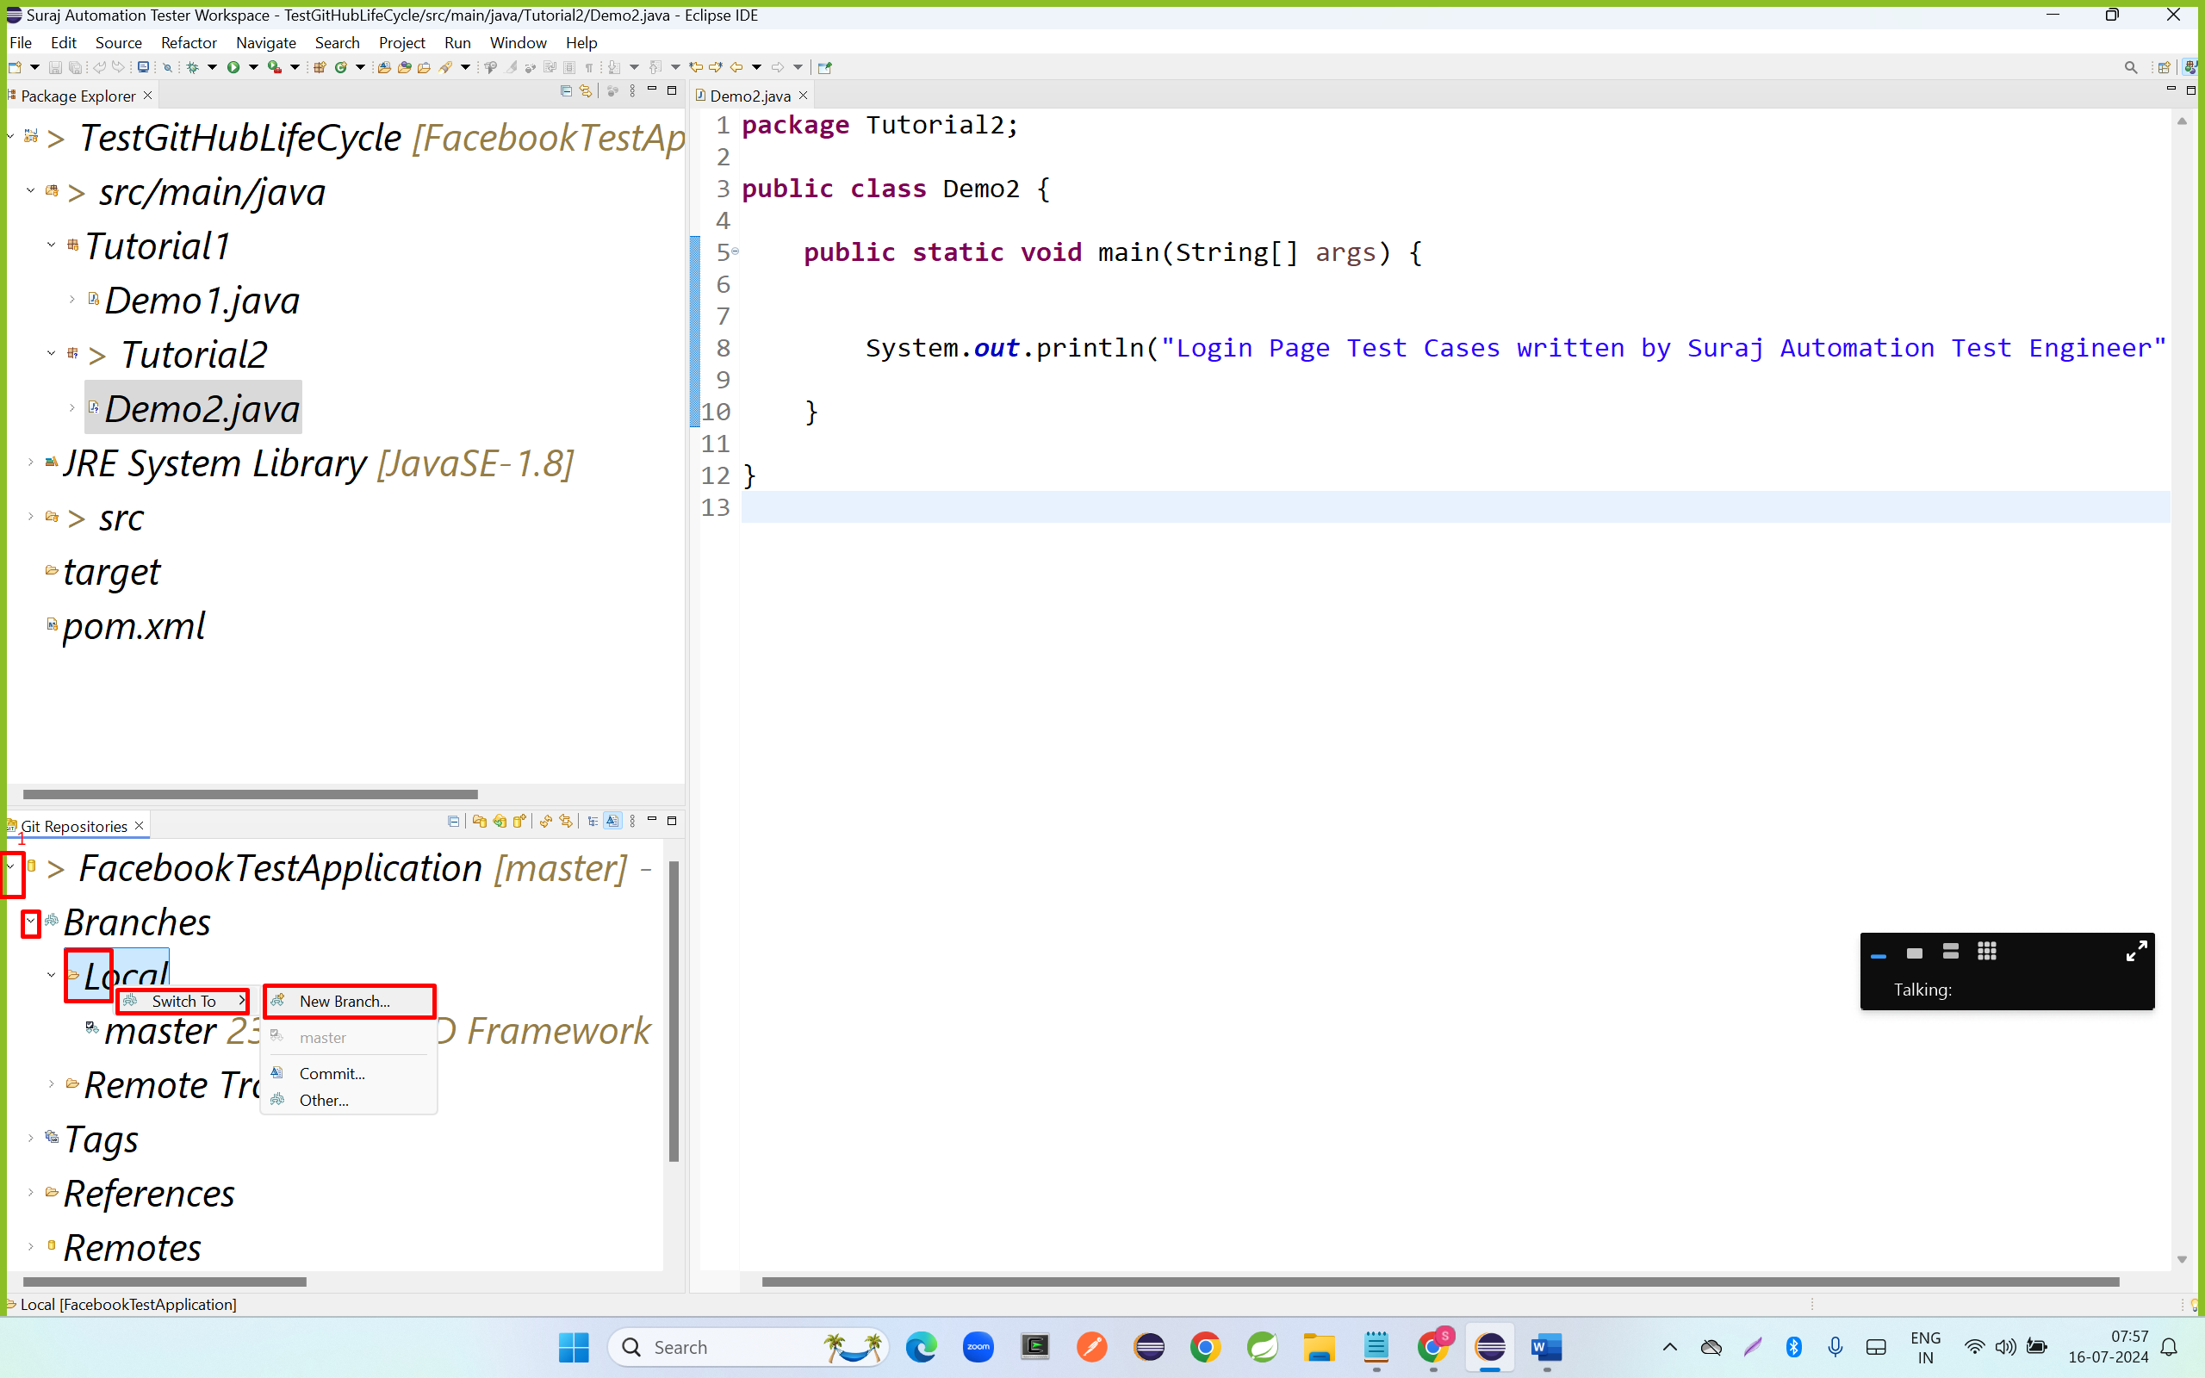

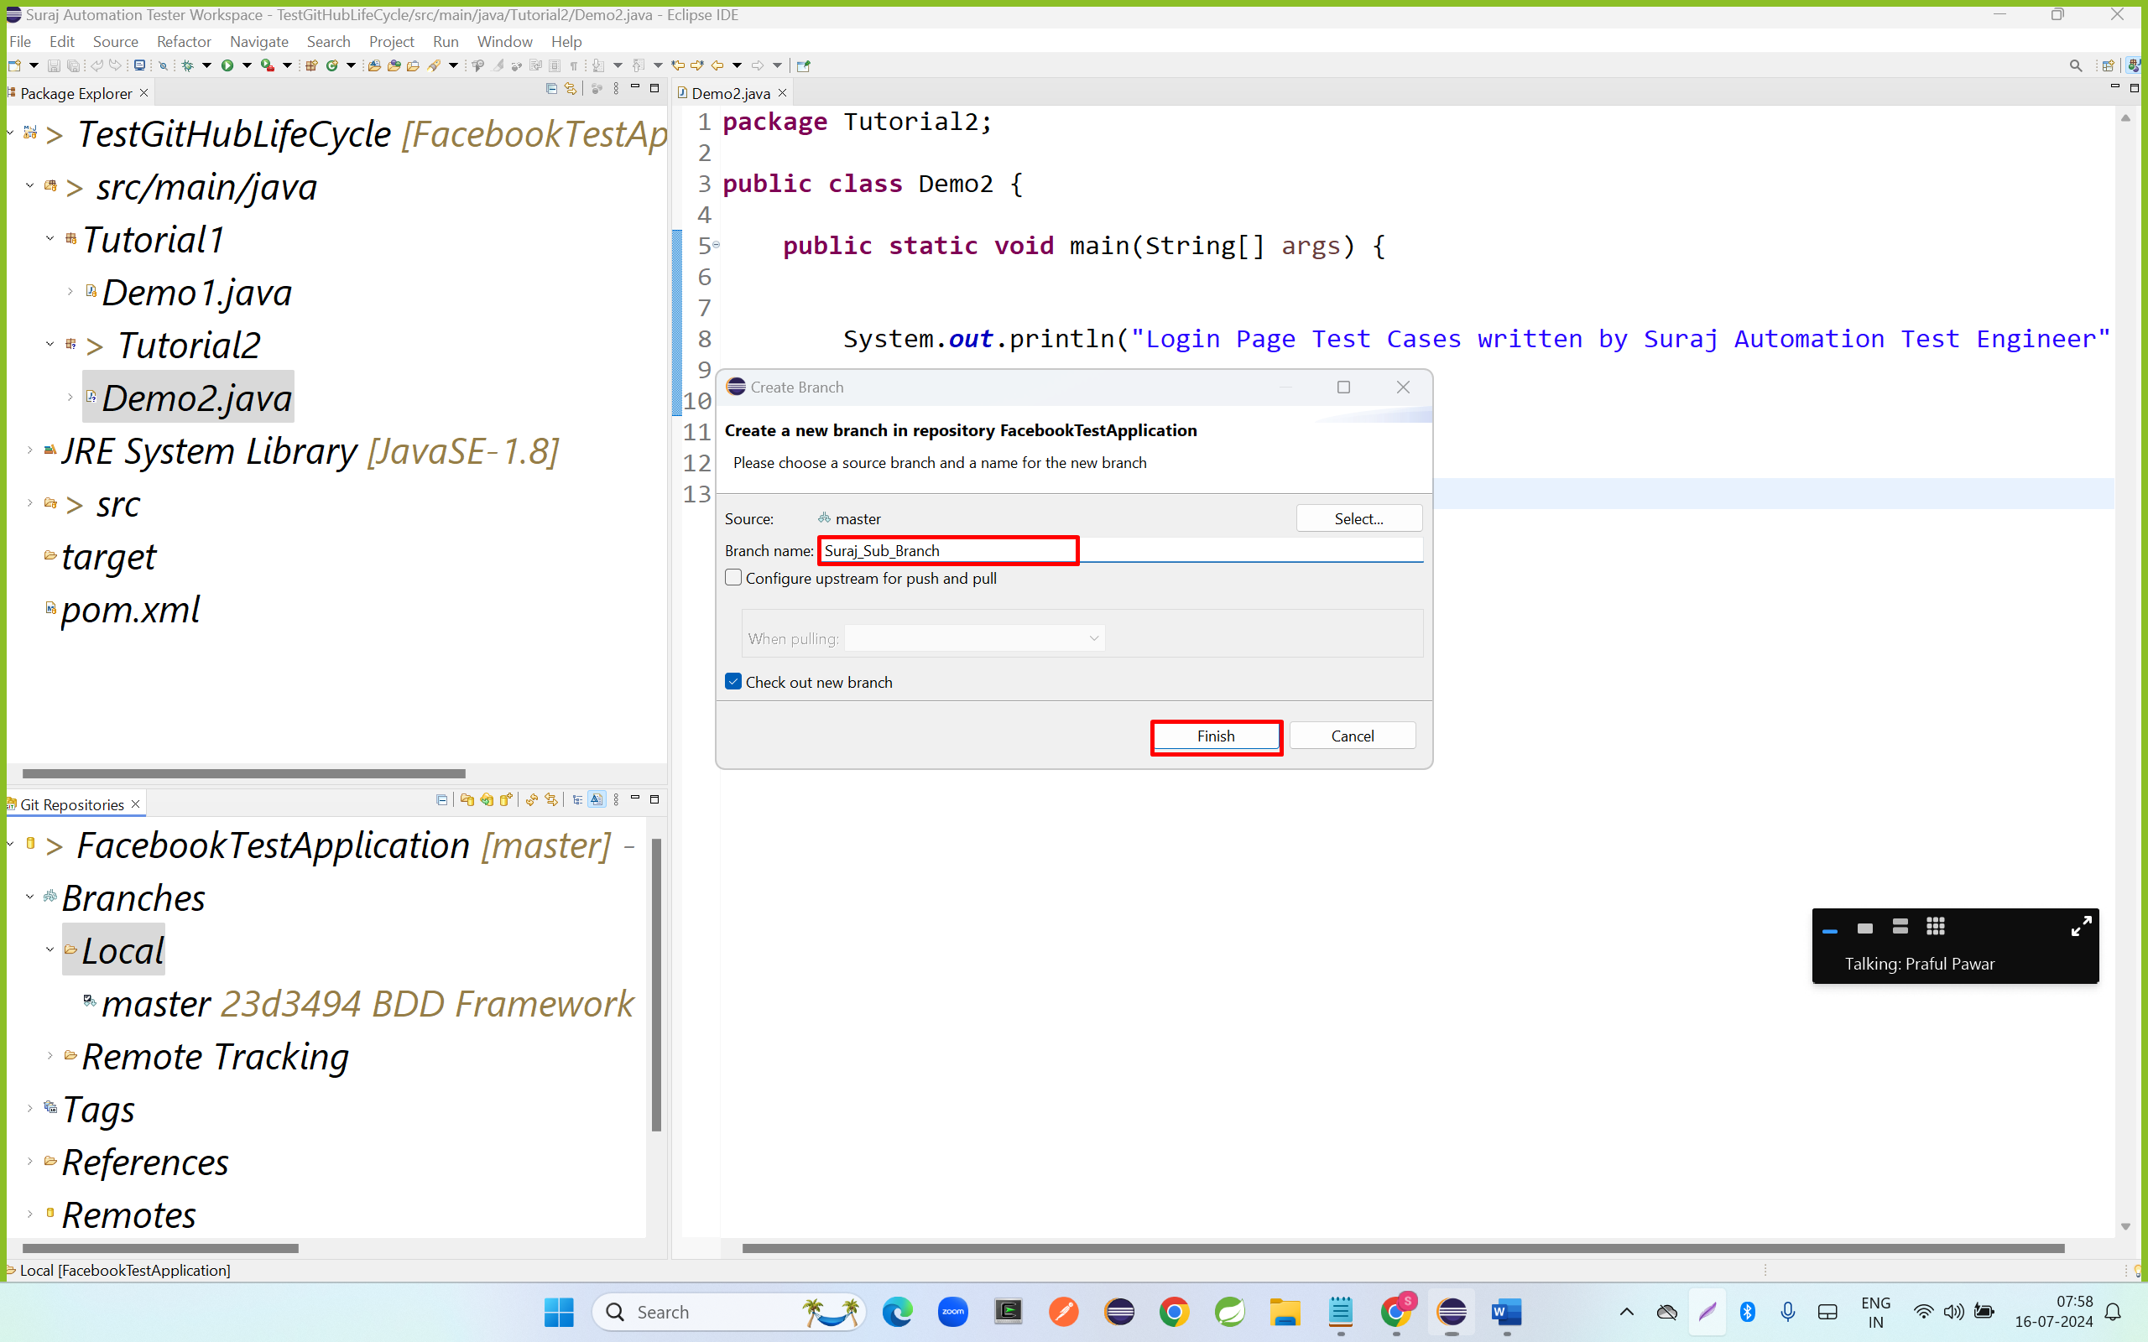

* Step 3: Checkout to sub branch

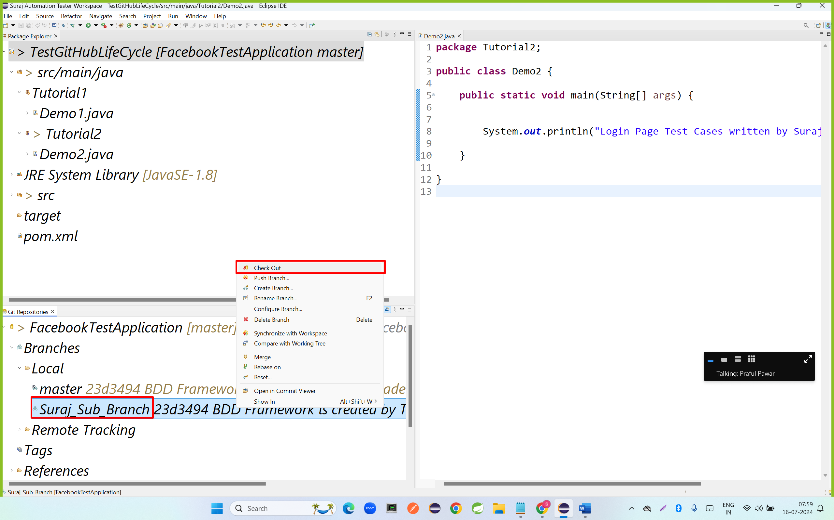

* Step 4: Add files to stagging area

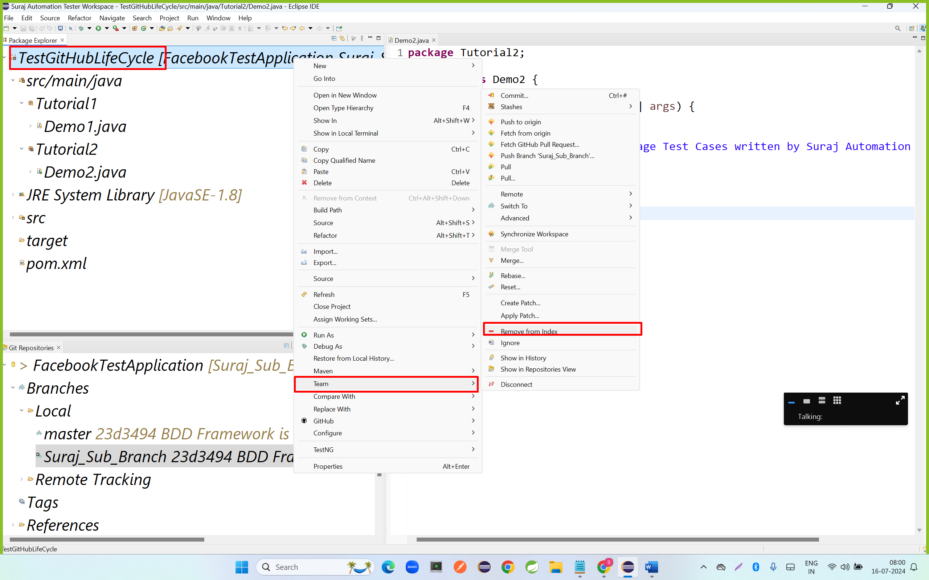

* Step 5: commit code to git local repository

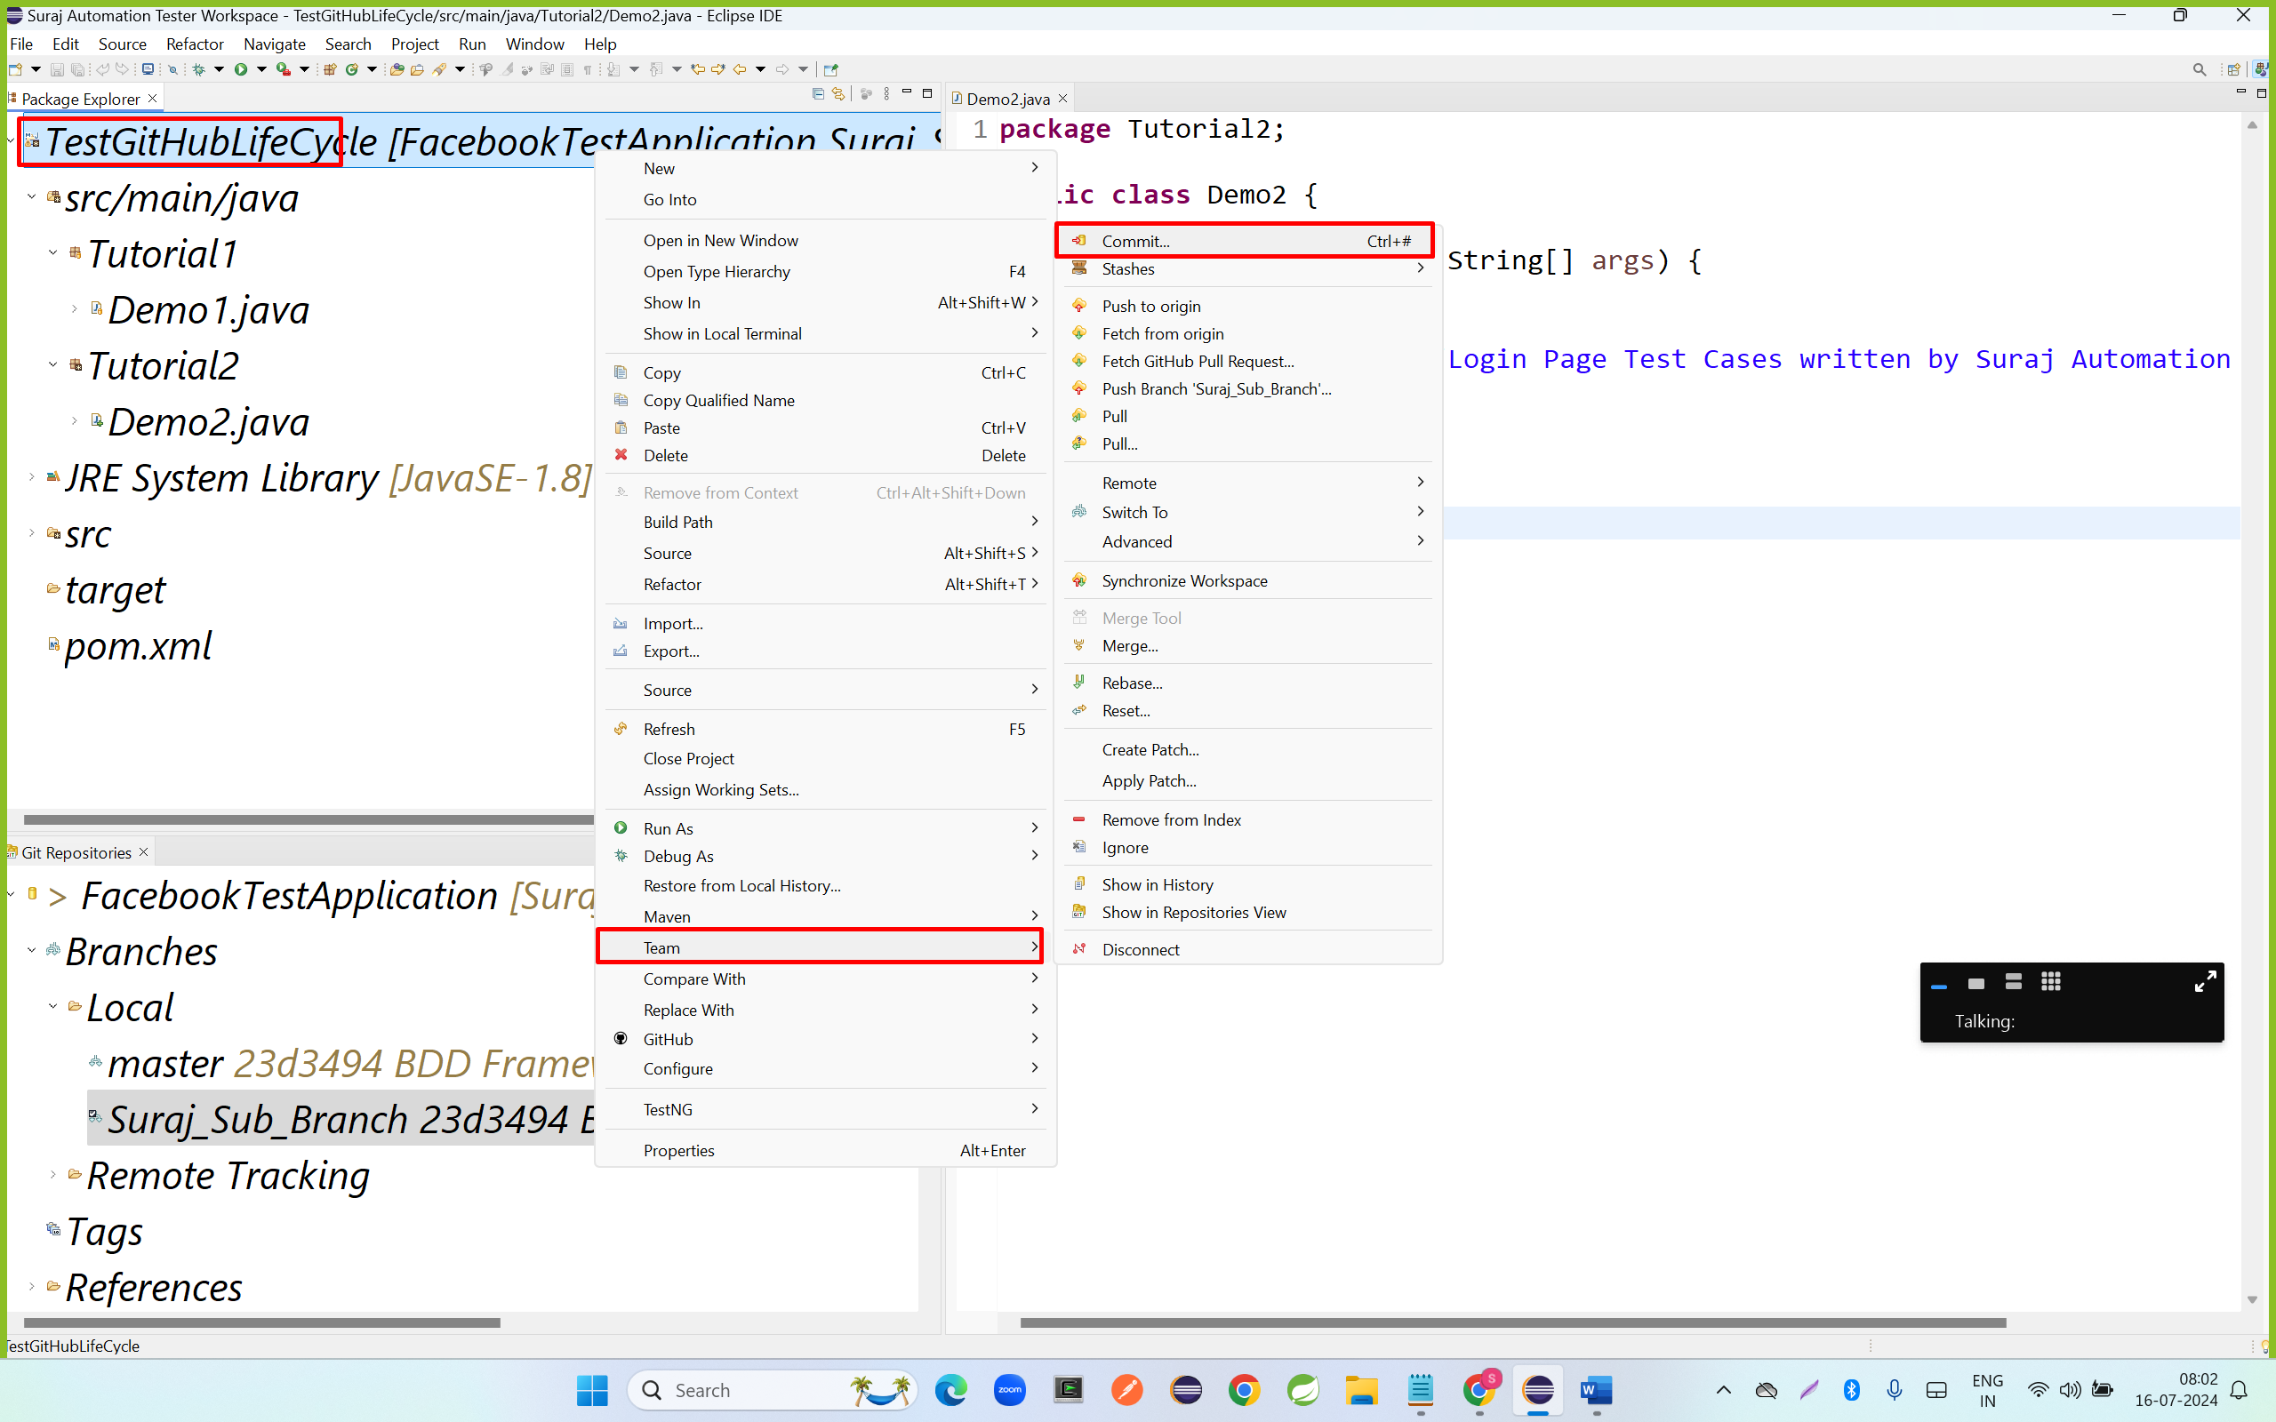

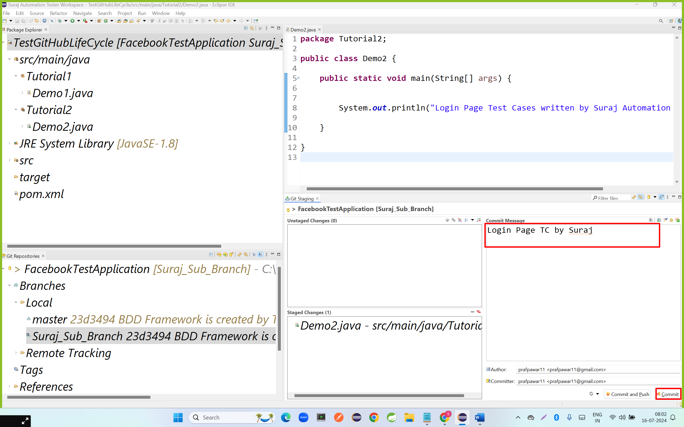

* Step 7: push code to Suraj Sub branch
  + Right click on project—go to team – click on Push Suraj Sub Branch

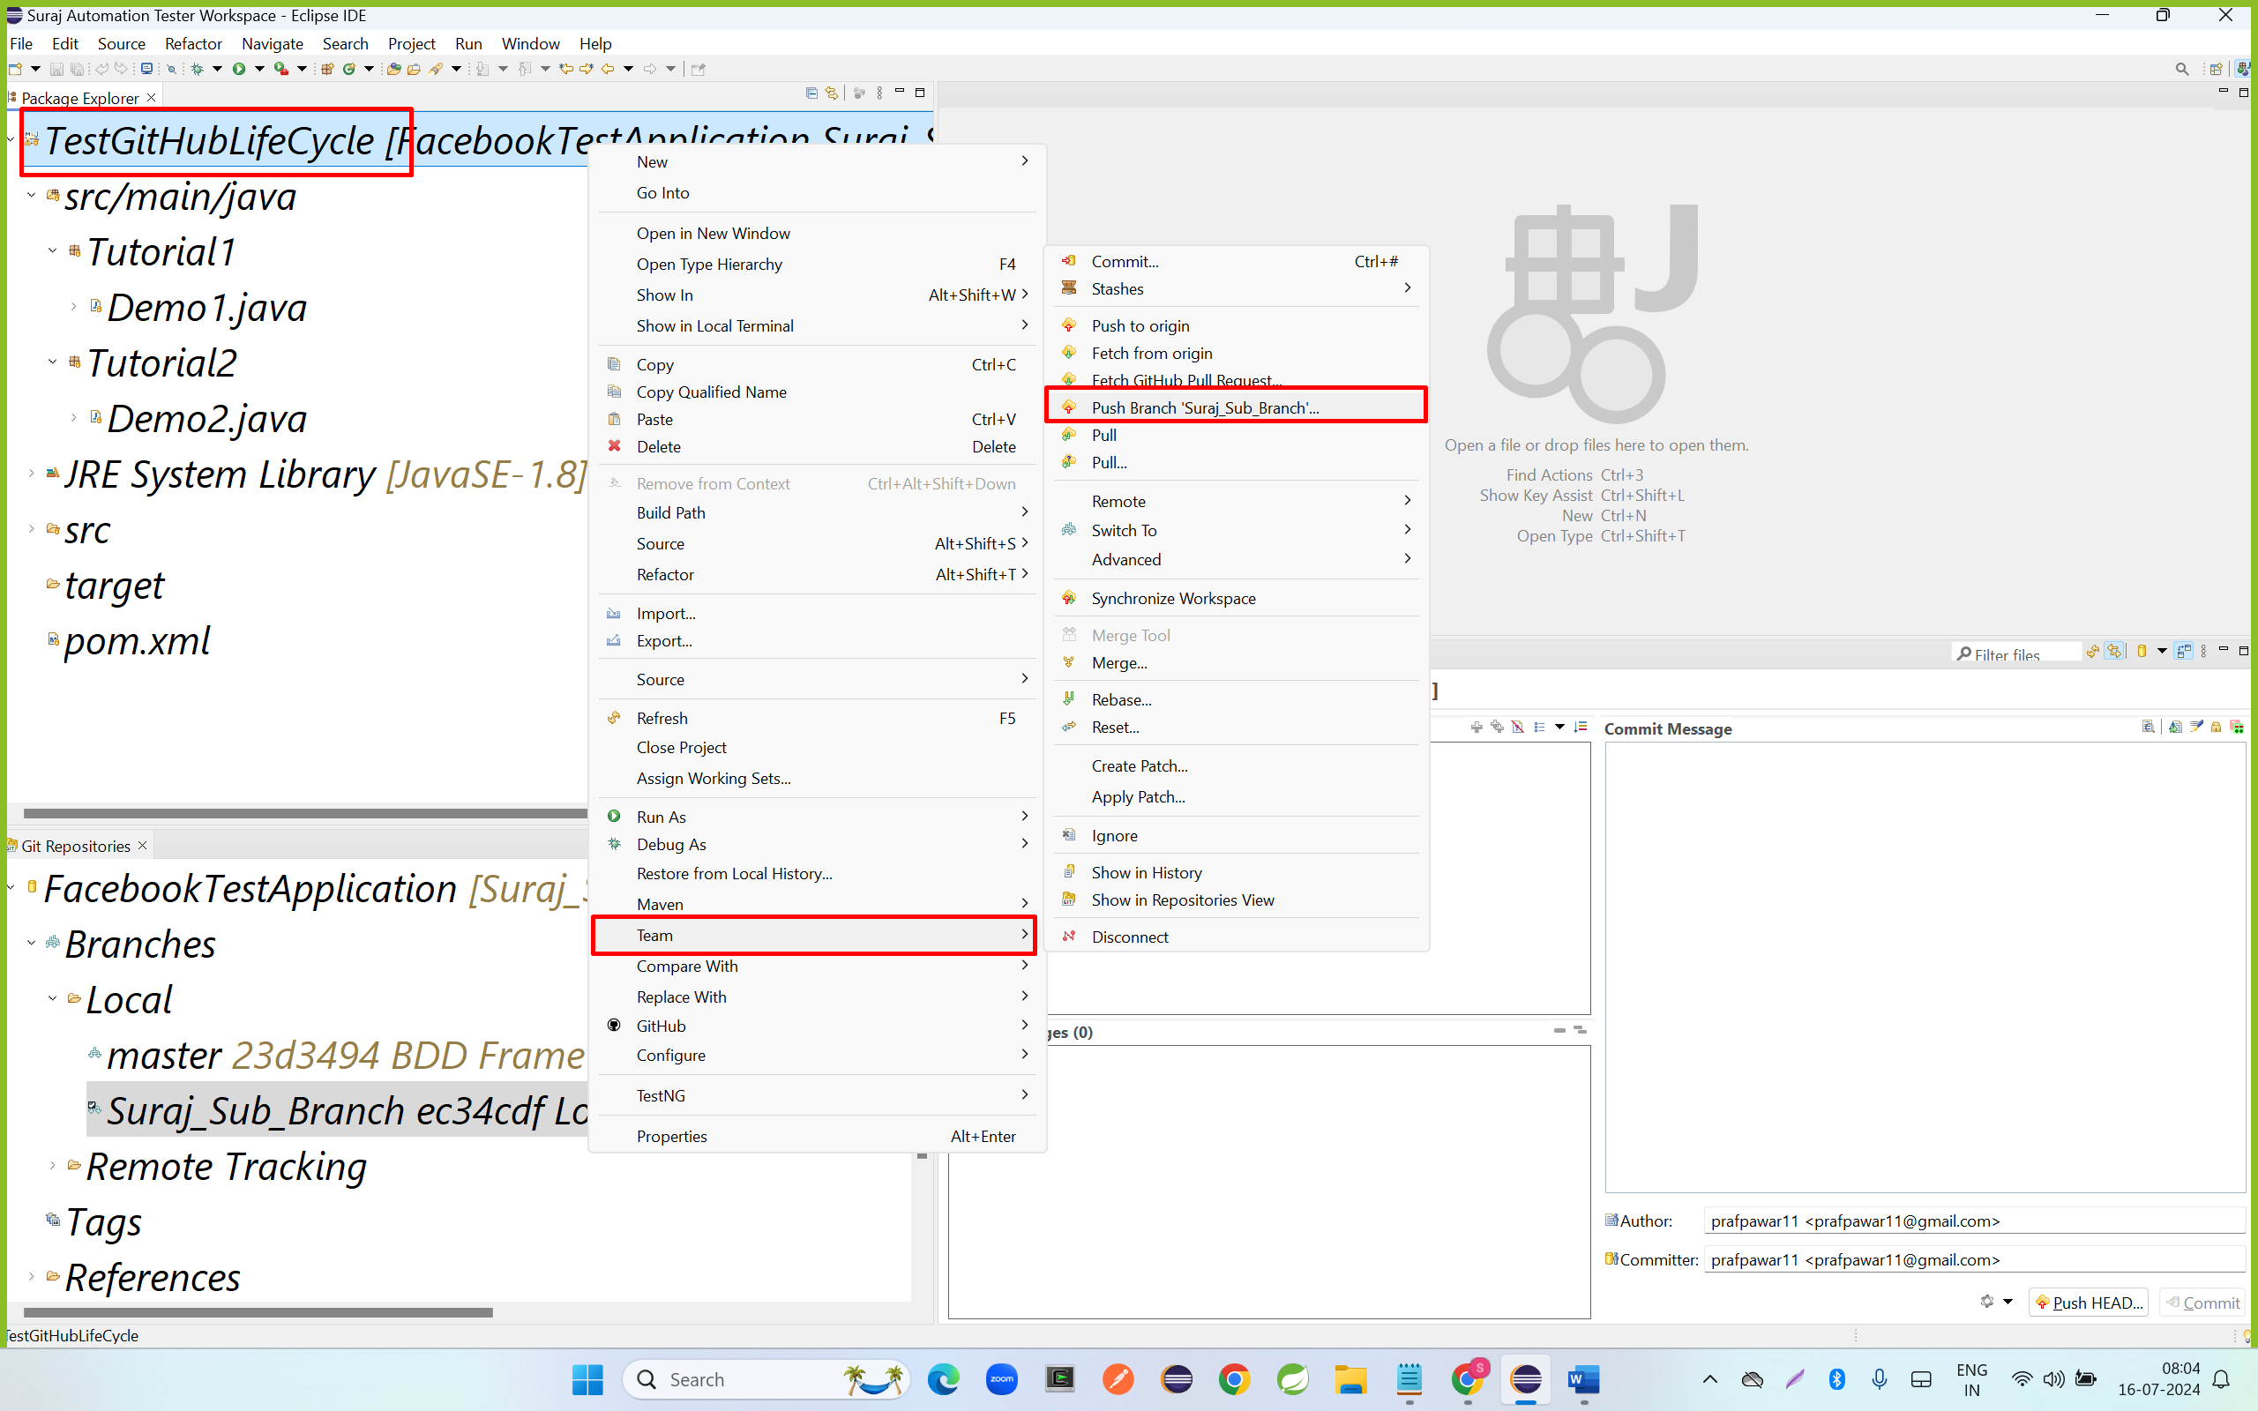

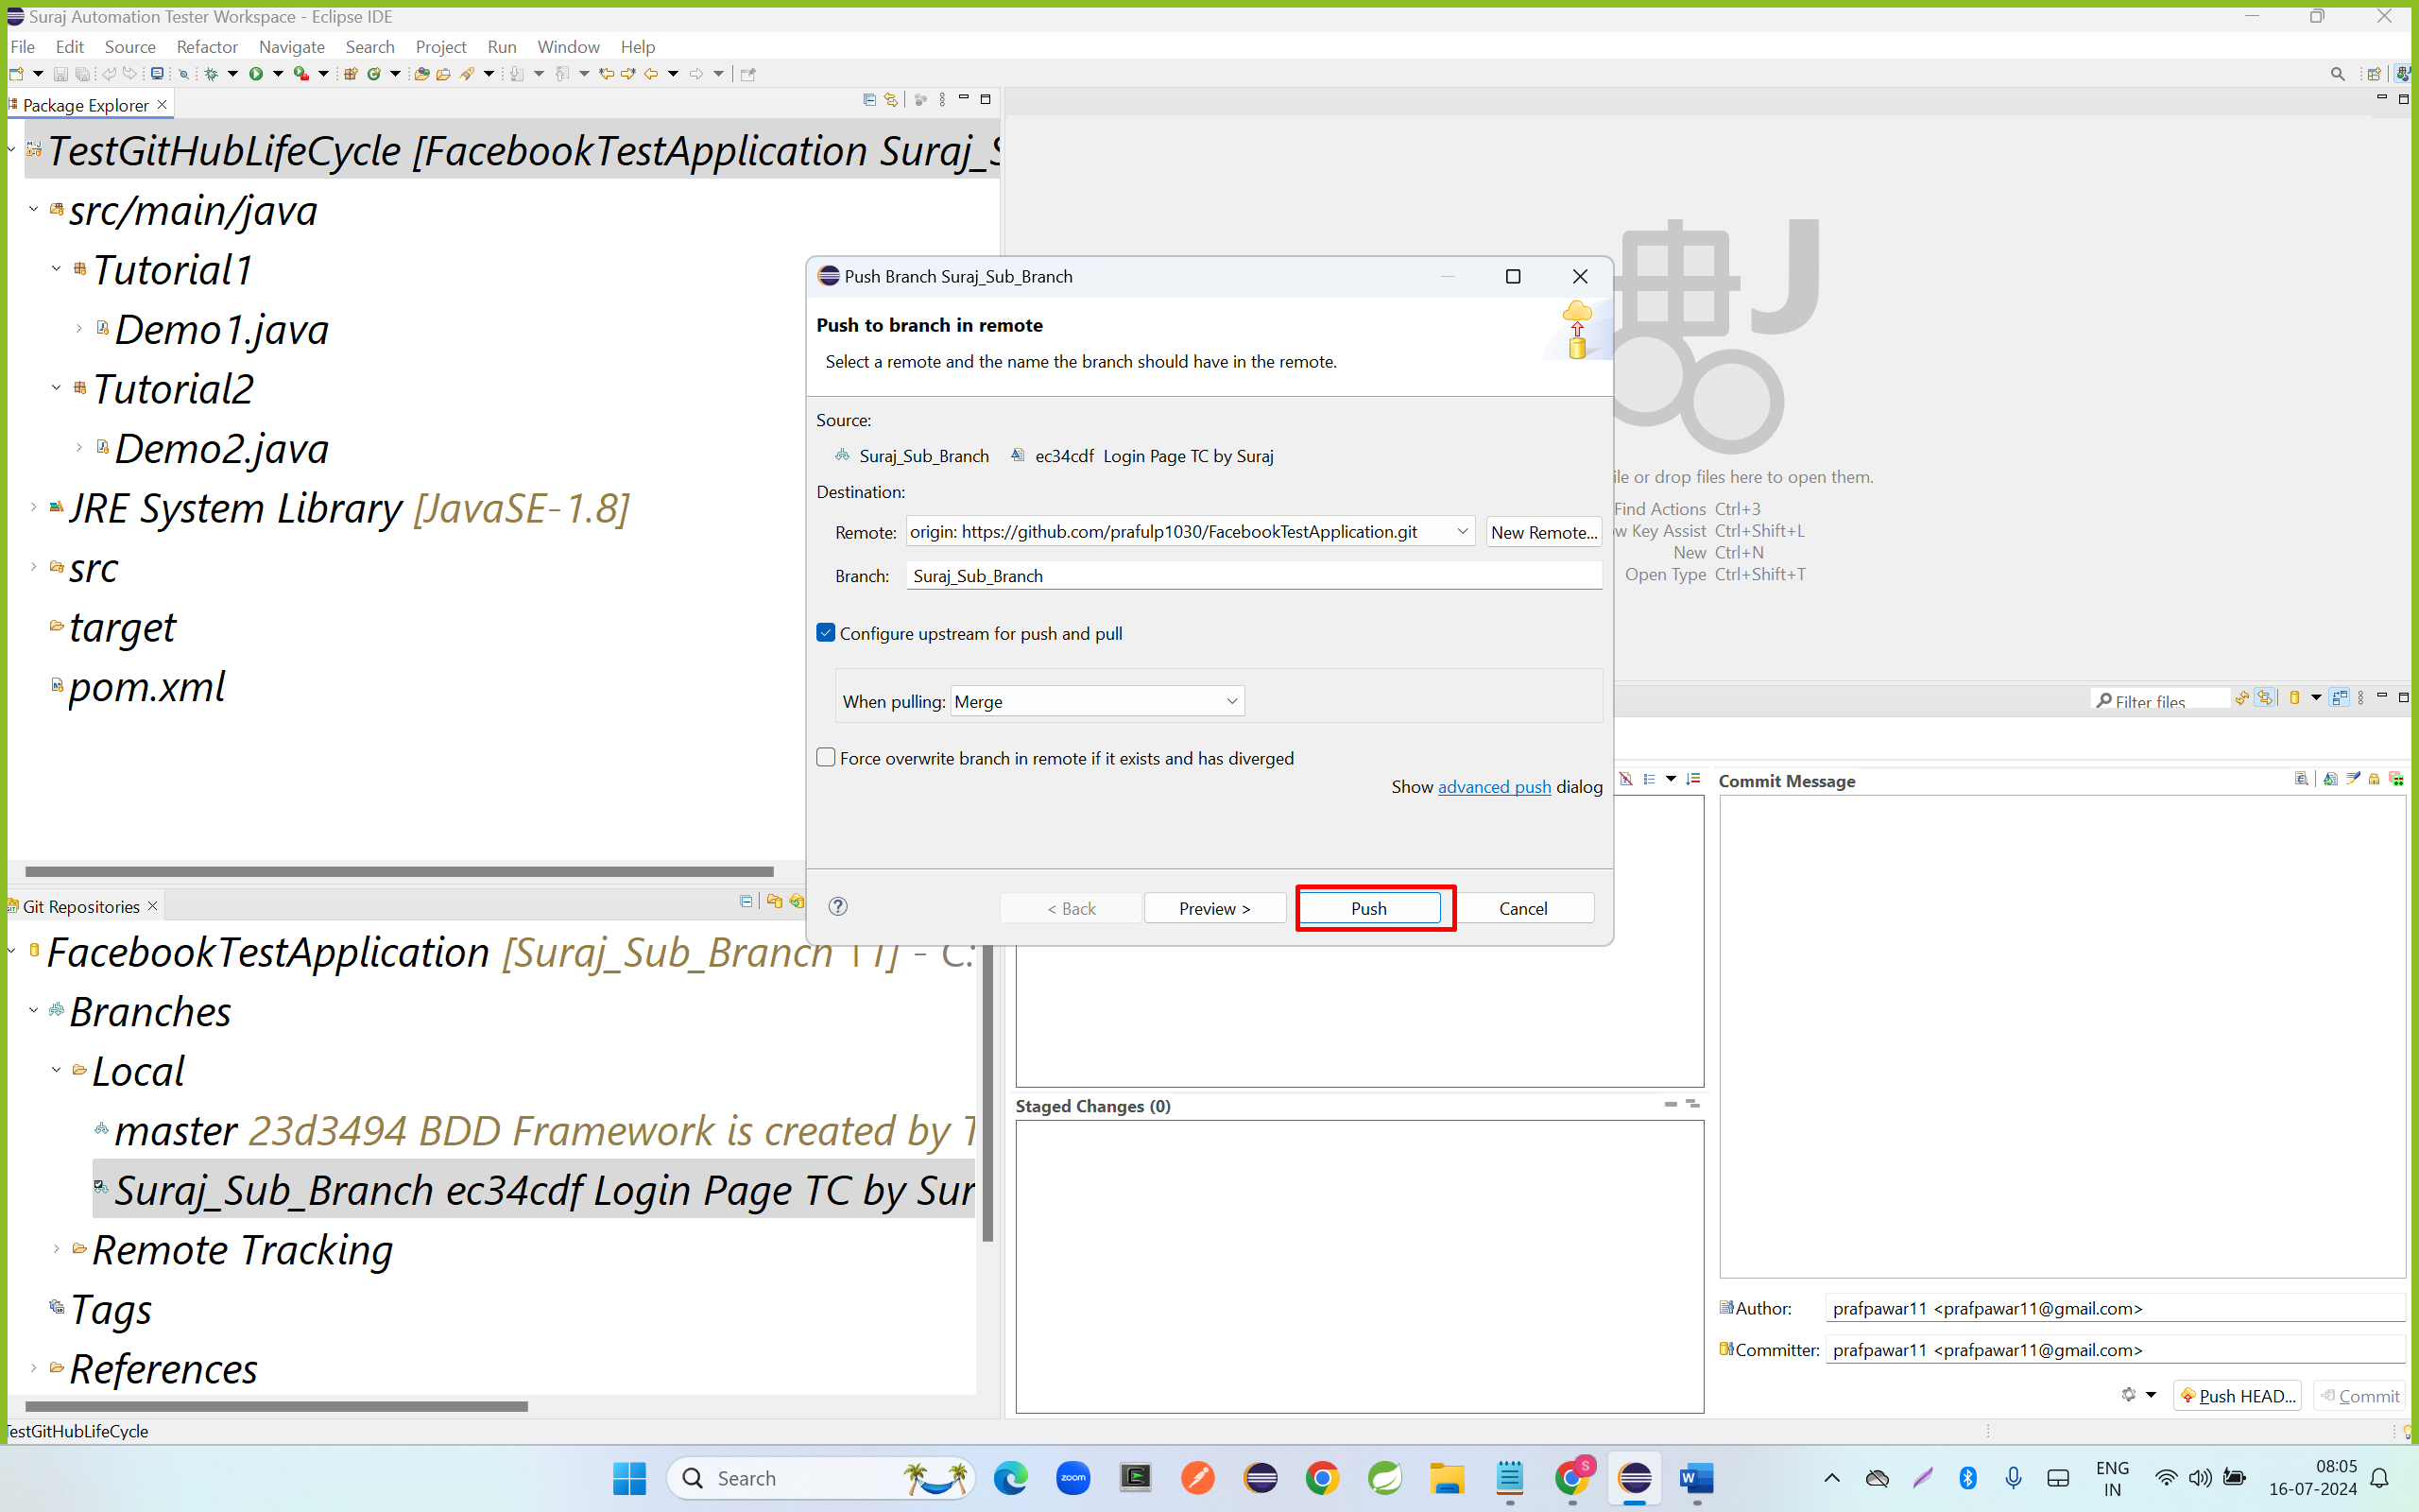

Step 8: Team leader will review the Sub Branch Test Cases.

Step 9: Merge code to the Master branch In GitHub Remote Repository

* Go to GitHub Repository
* Click on Pull Request

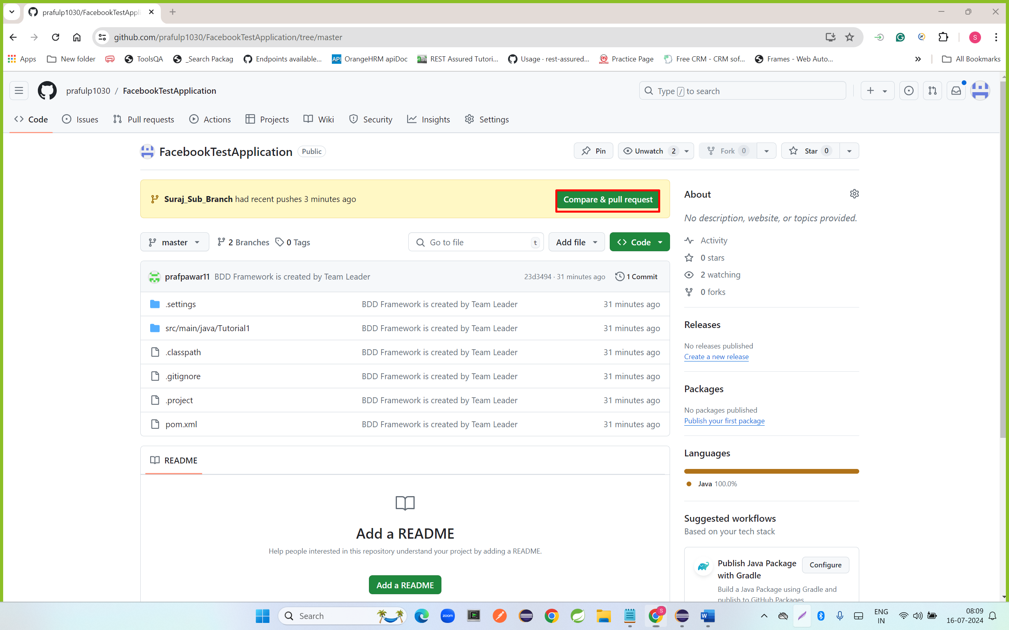

* Verify the Pull Request to and from
* Enter the Pull Request message name
* Click on pull Request

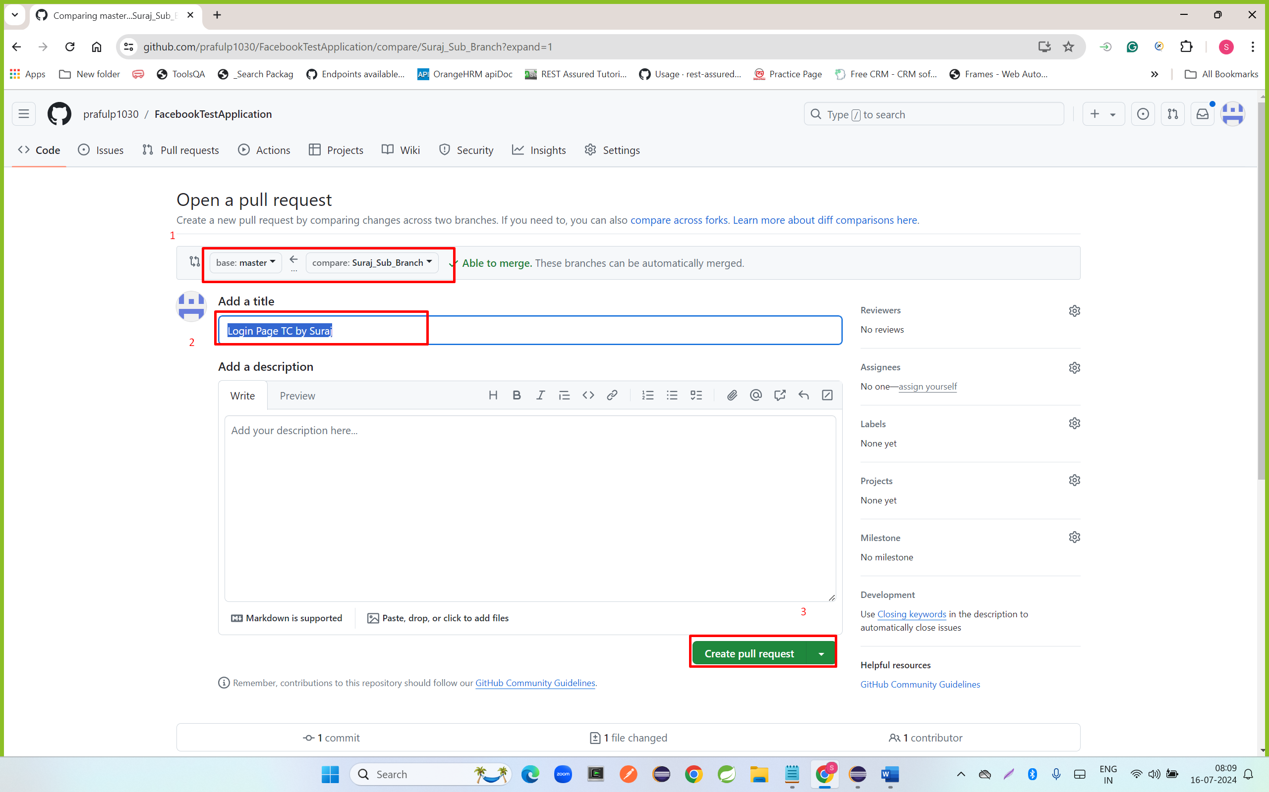

* Click on merge pull Request

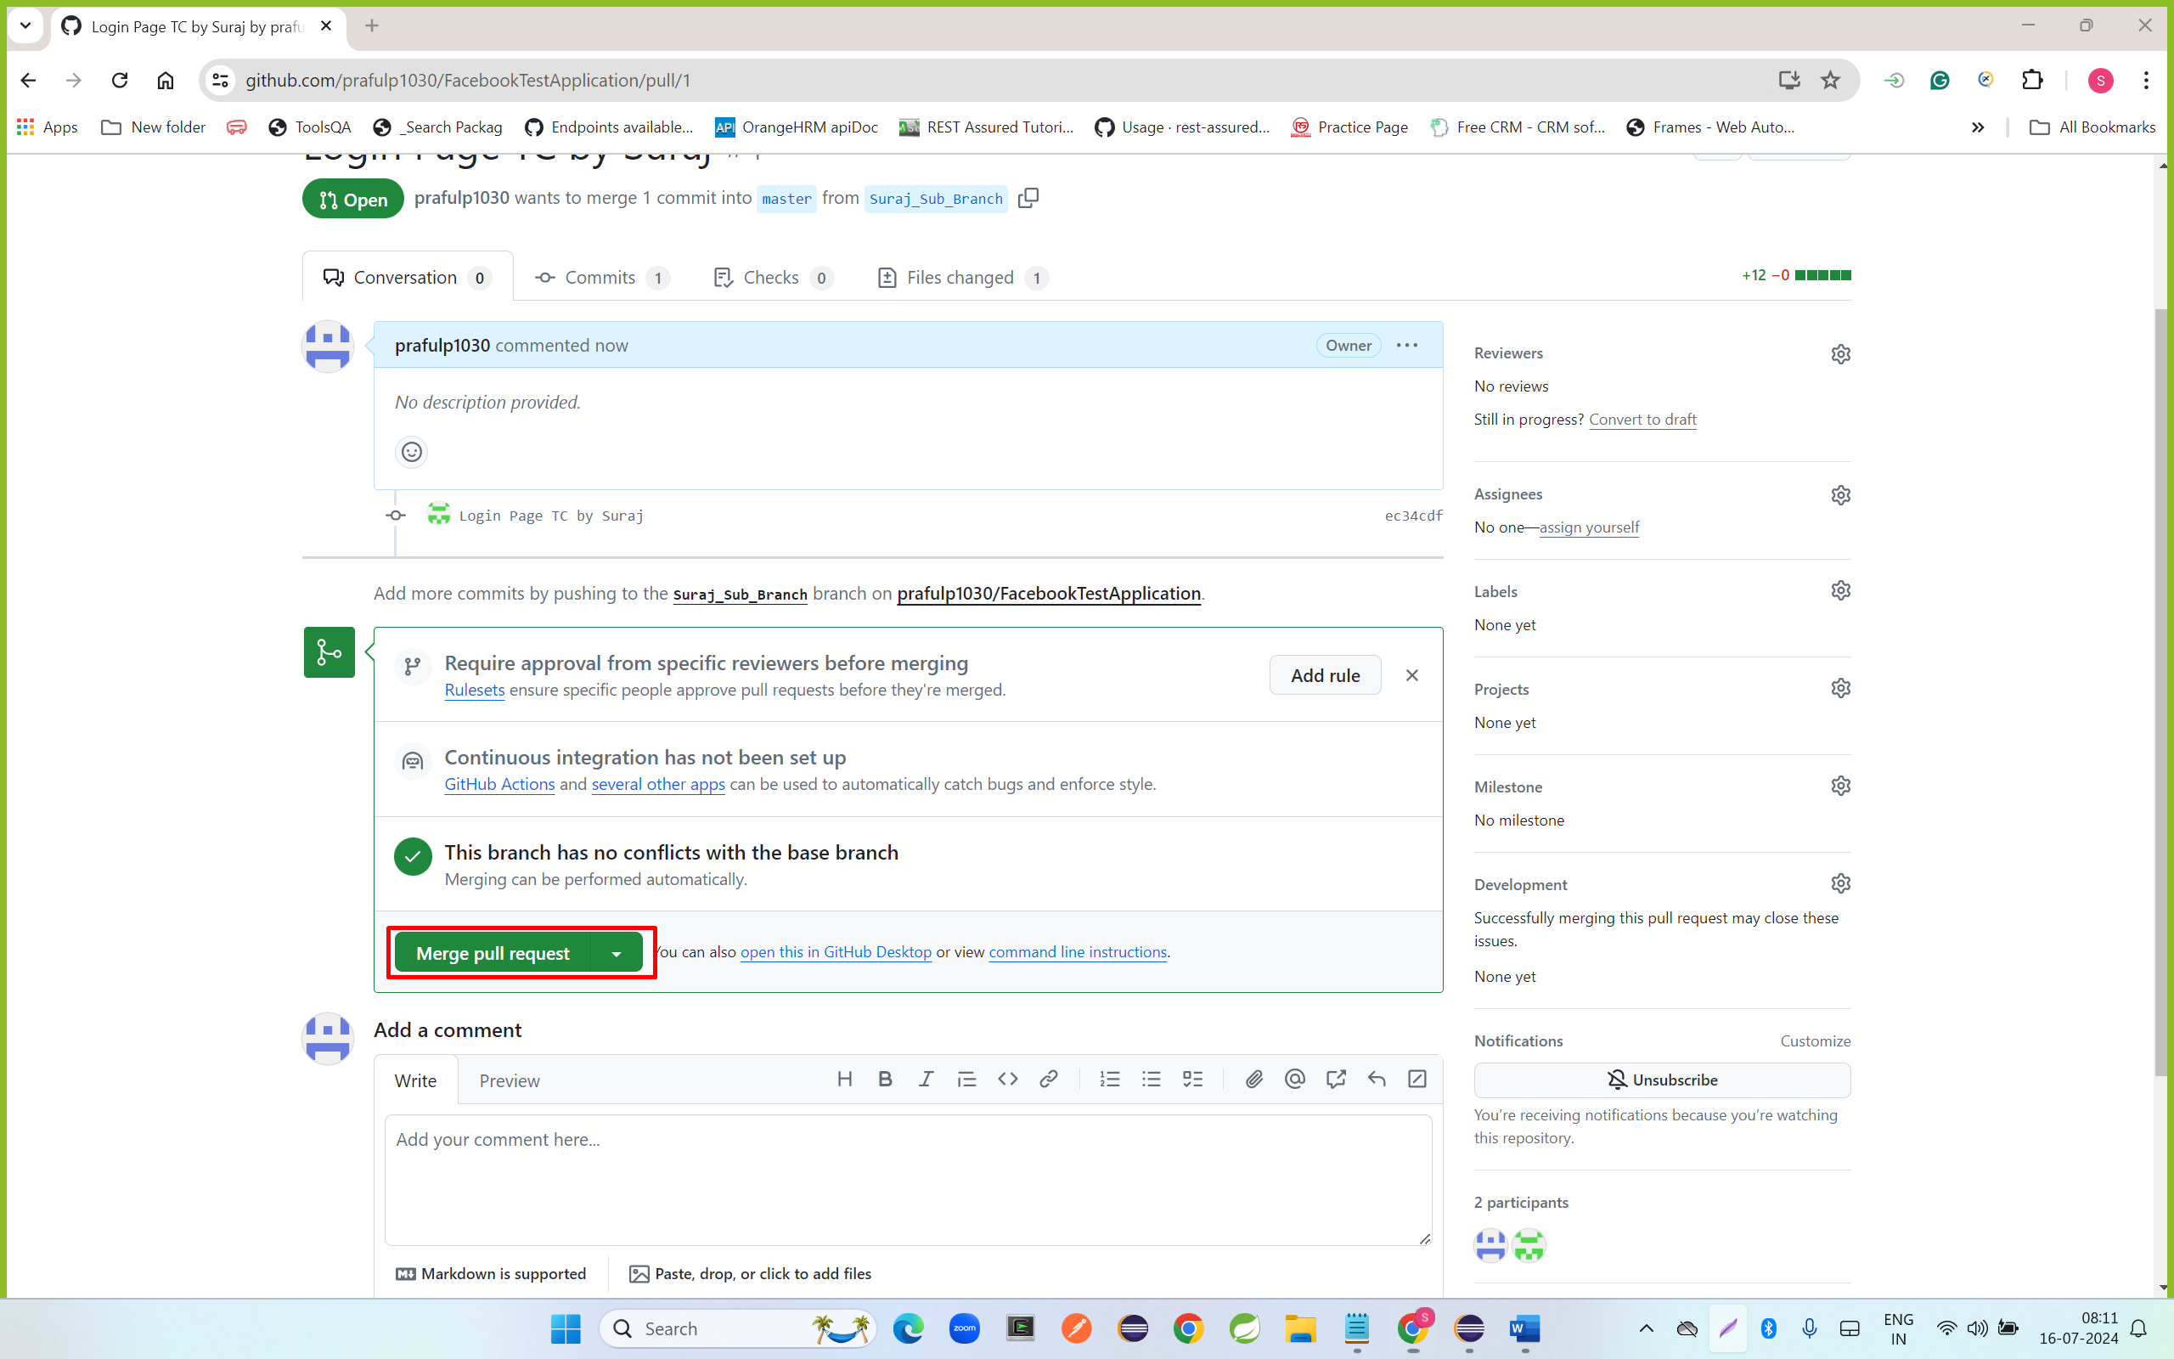

* Click on confirm merge

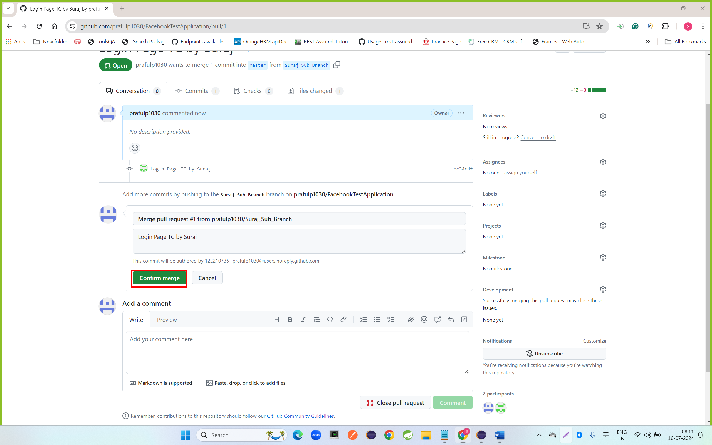

**Monali Automation Tester**

* Pull code from Remote Master GitHub
* Right click on project name ---- go team – click on pull

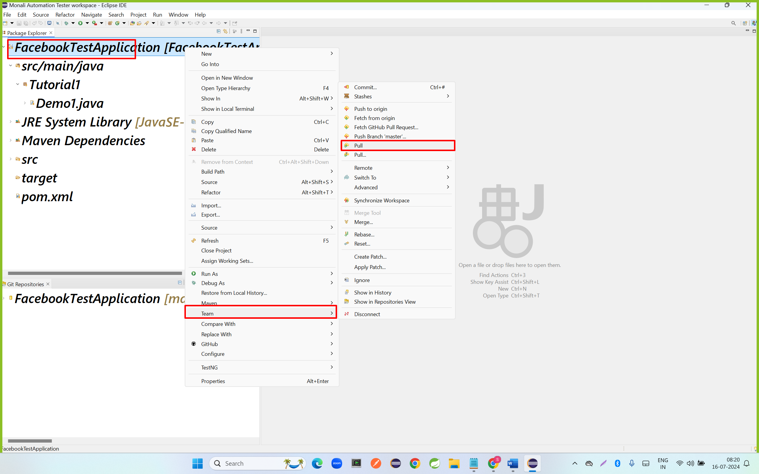

Step 3: create Monali Sub Branch

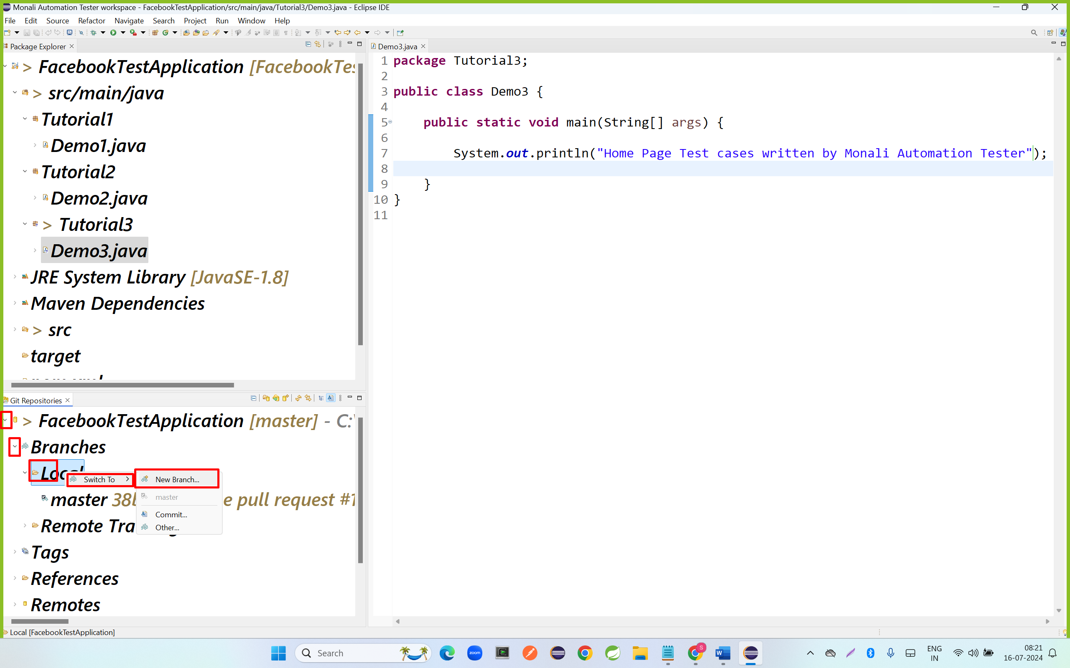

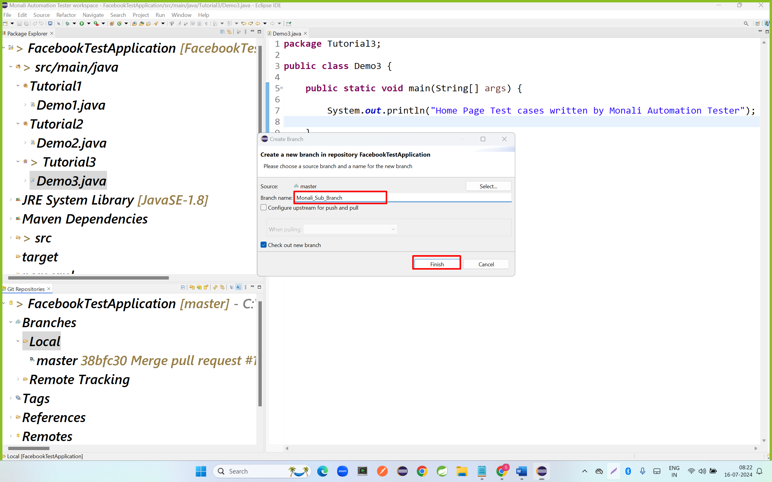

Step 4: add files to stagging area

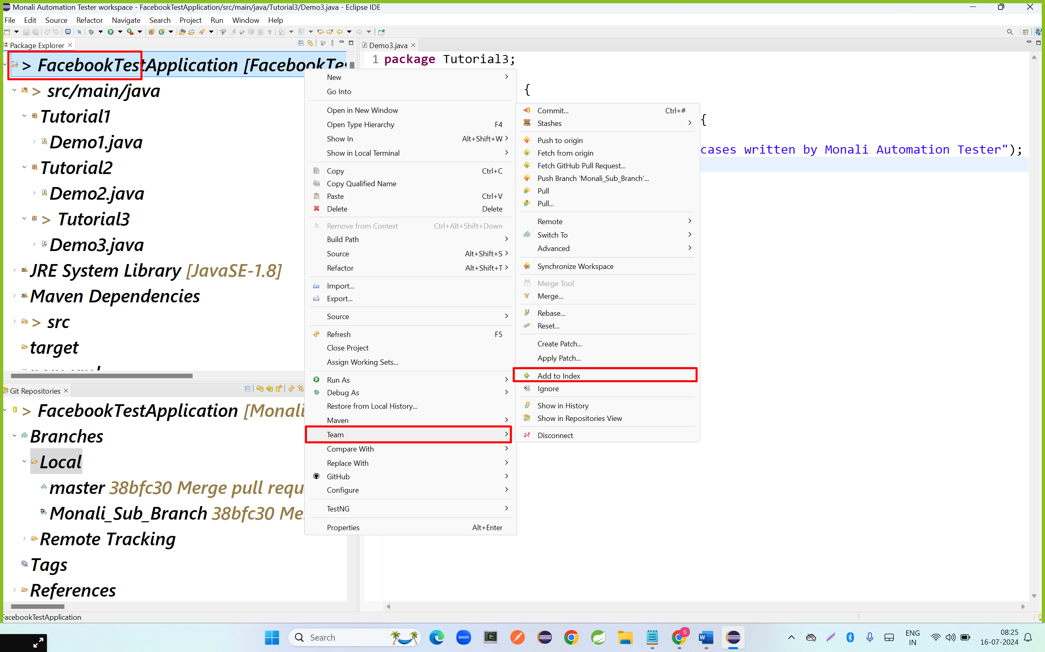

Step 5: commit code to git local repository

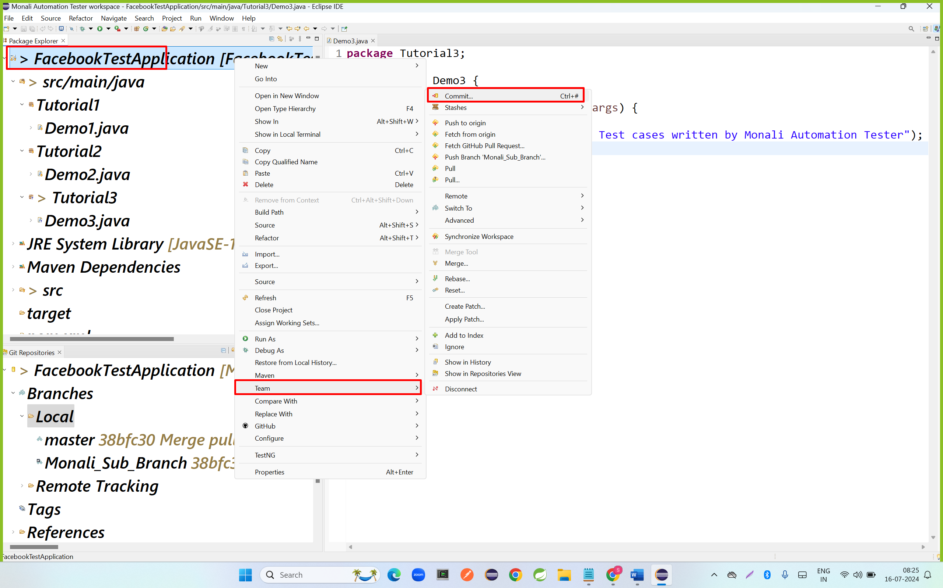

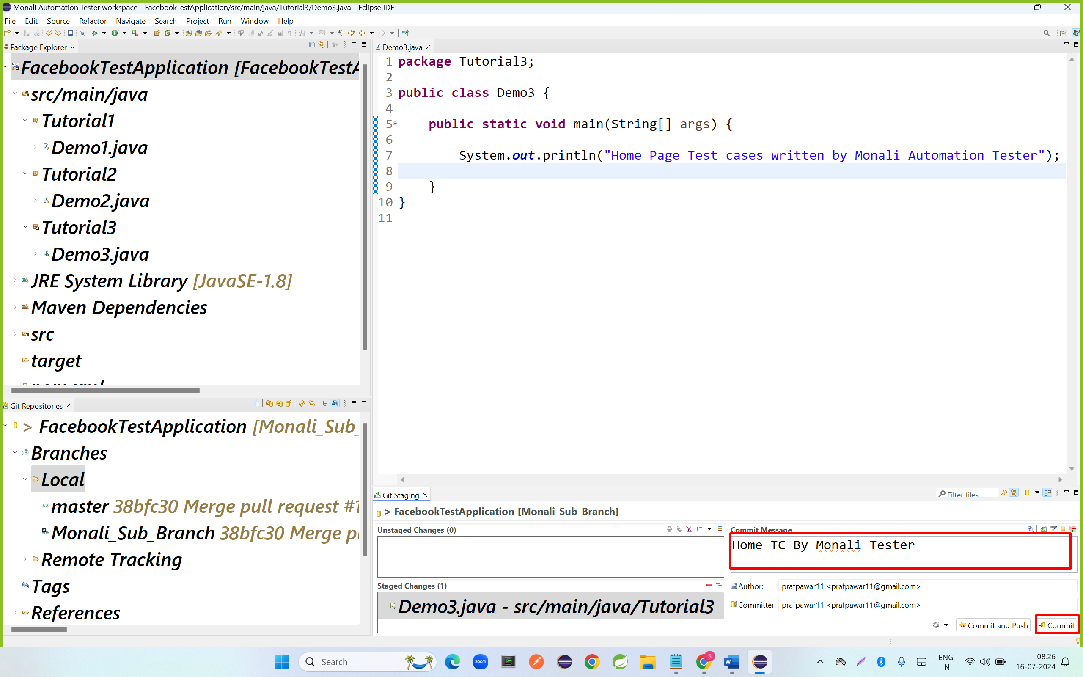

Step 6: push code to Monali Sub Branch

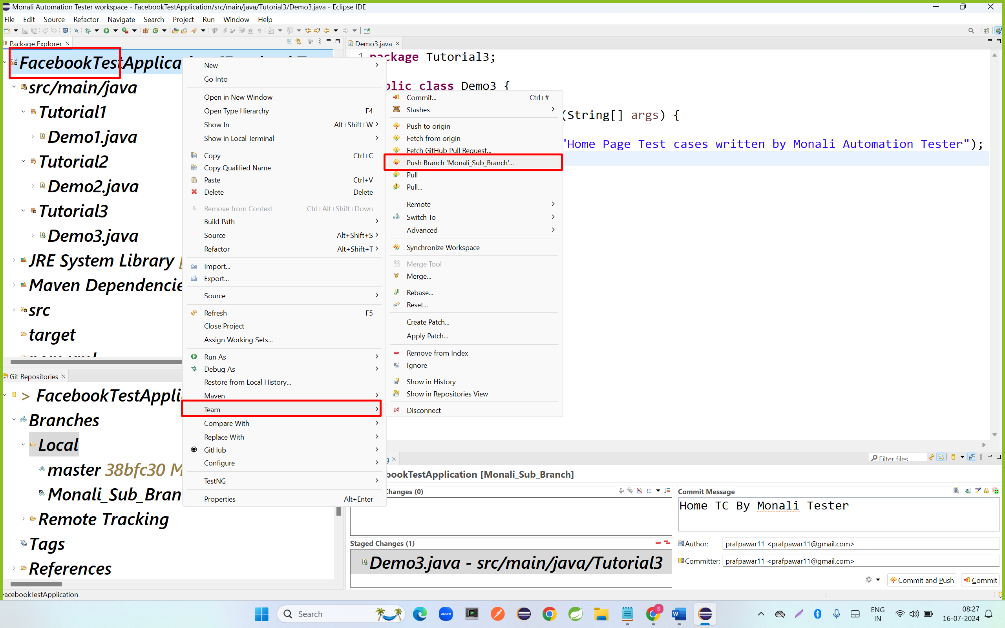

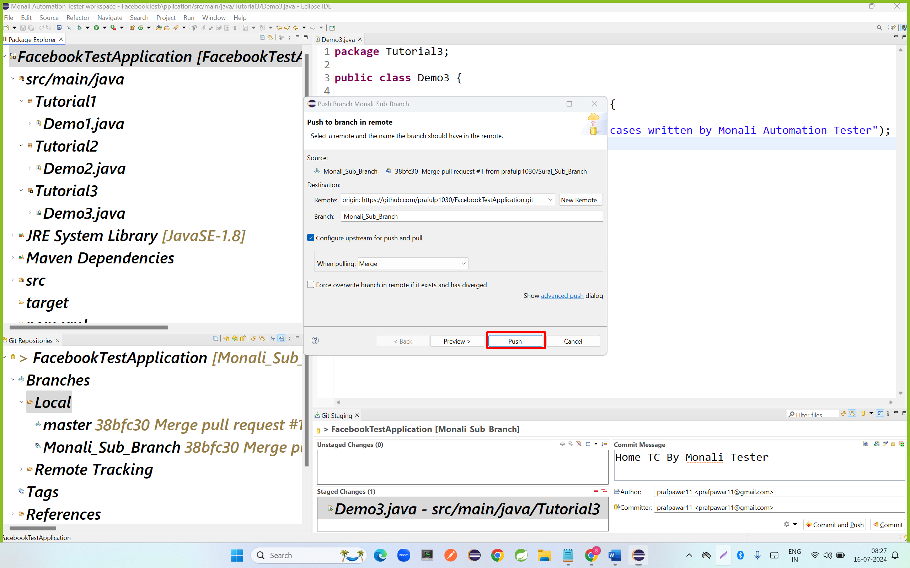

Step 7: Code Review by TL

Step 8: merge code to the Master branch

* Go to Monali Sub Branch
* Click on compare and pull Request
* Verify the Merge the (From And TO)
* Enter Merge message
* Click on Pull Request
* Click on confirm pull

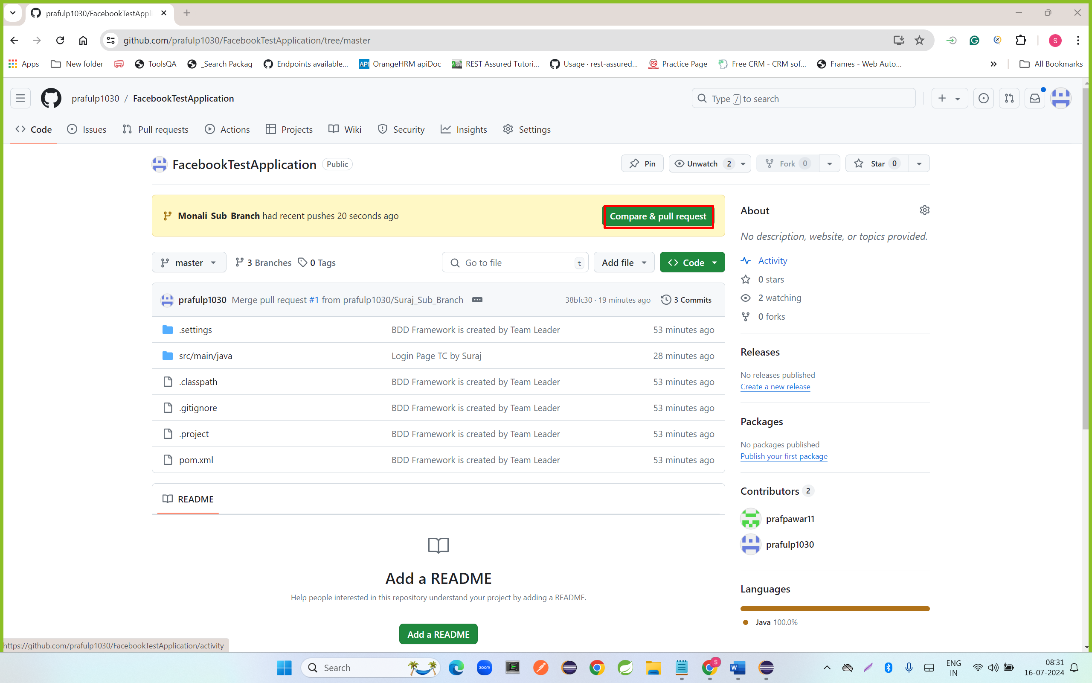

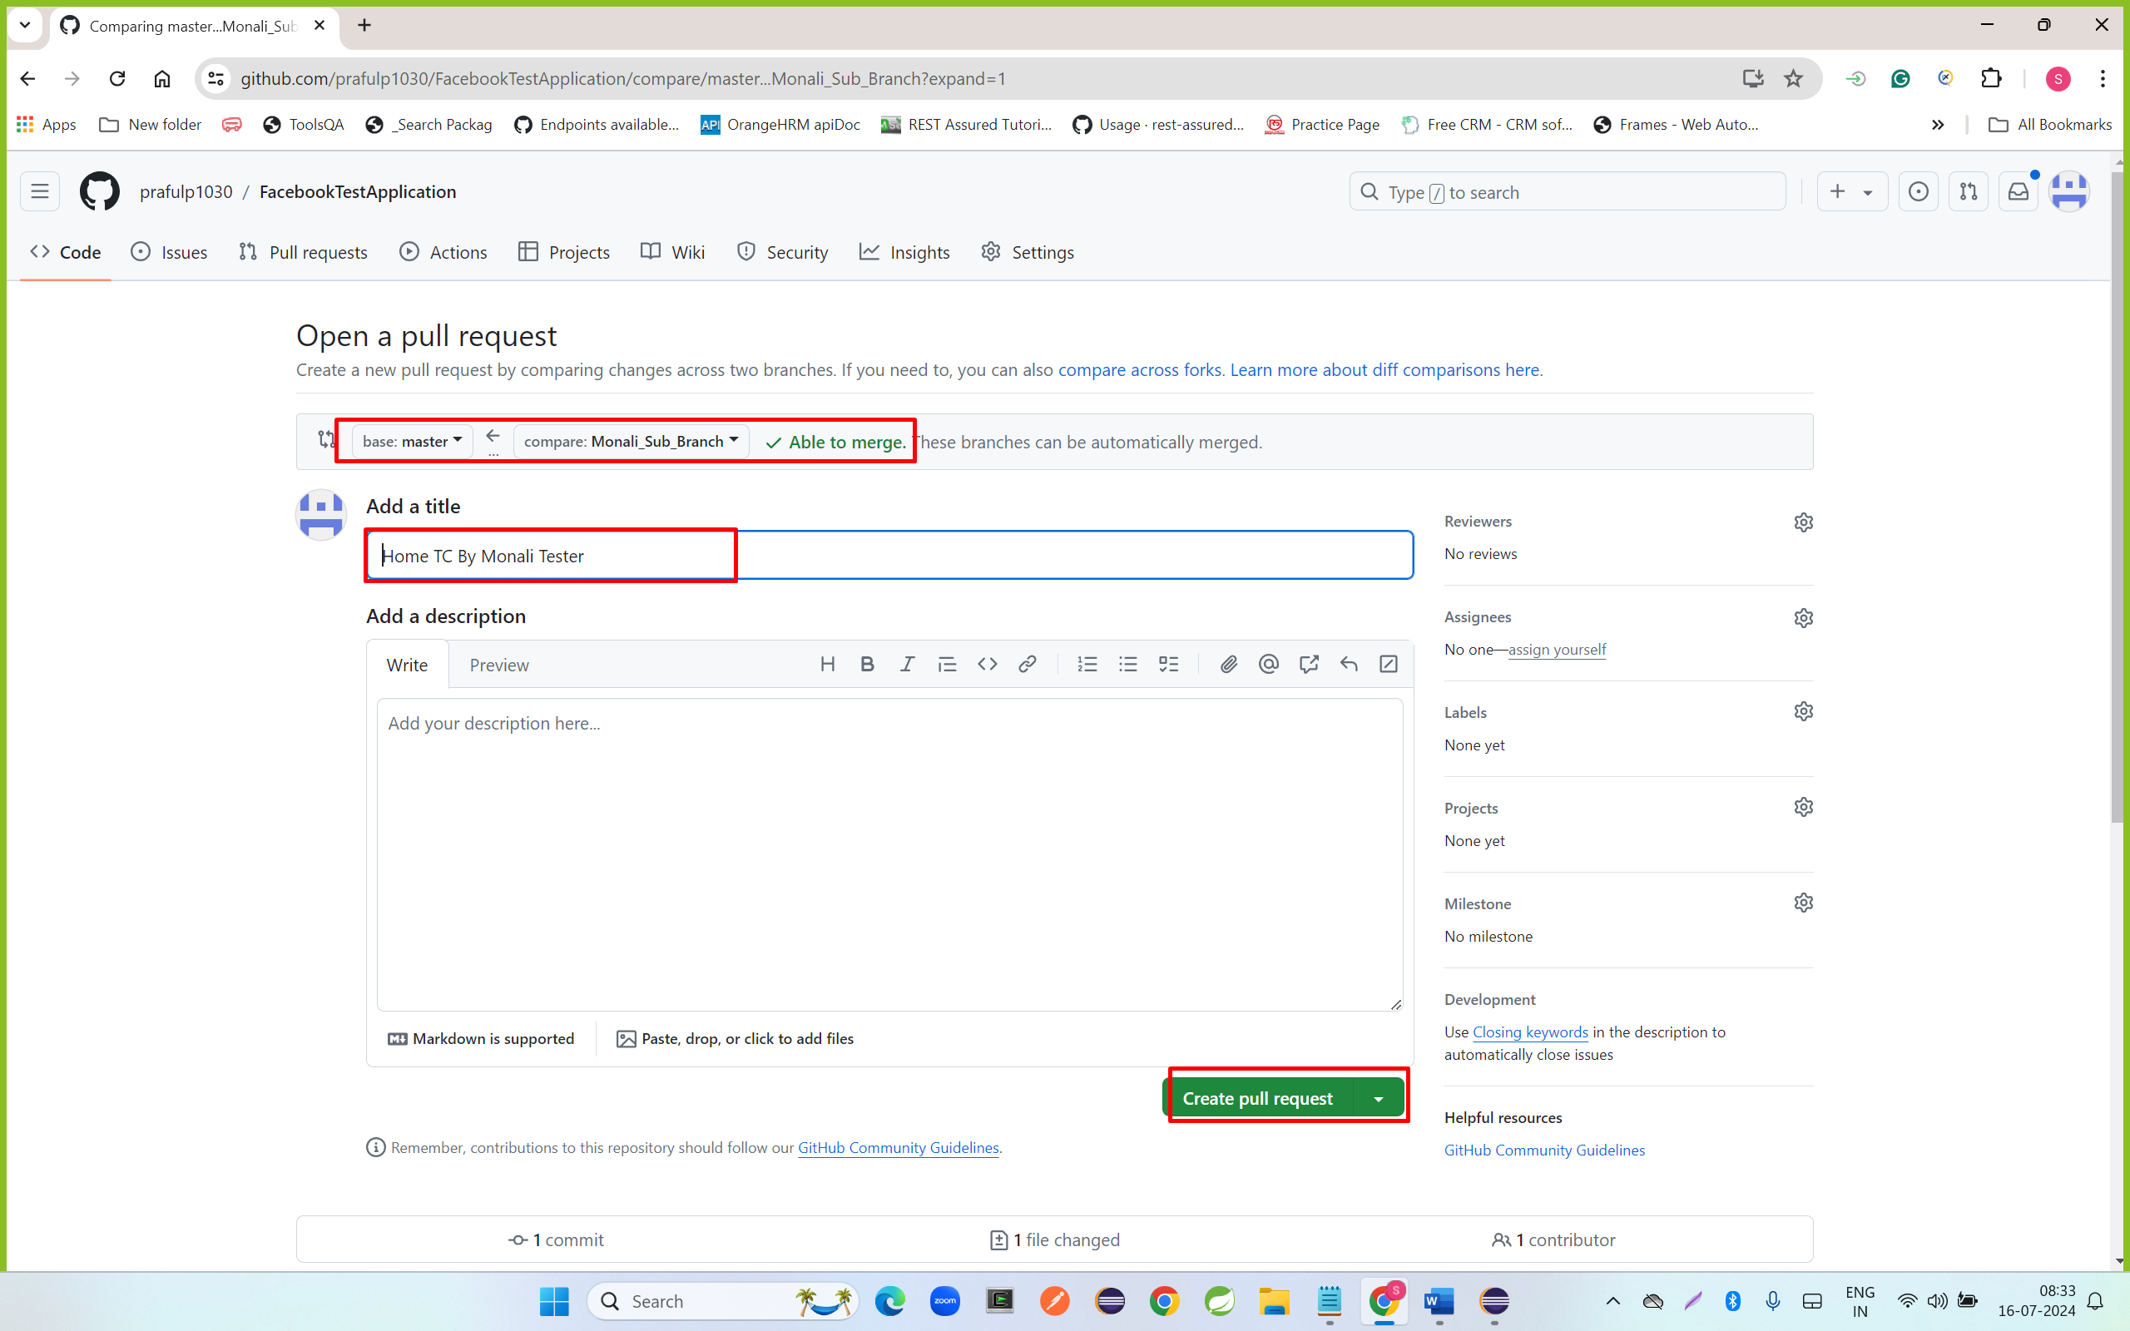

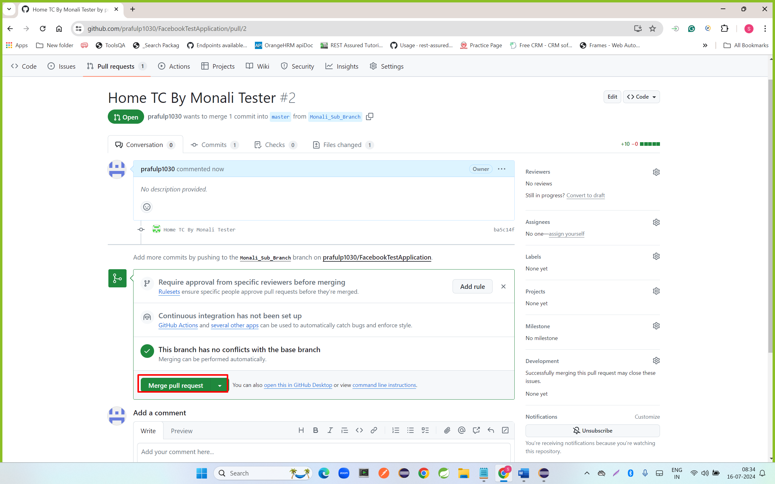

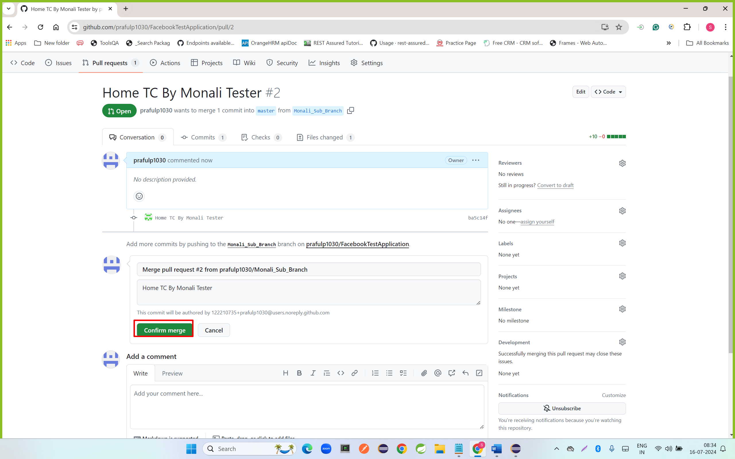

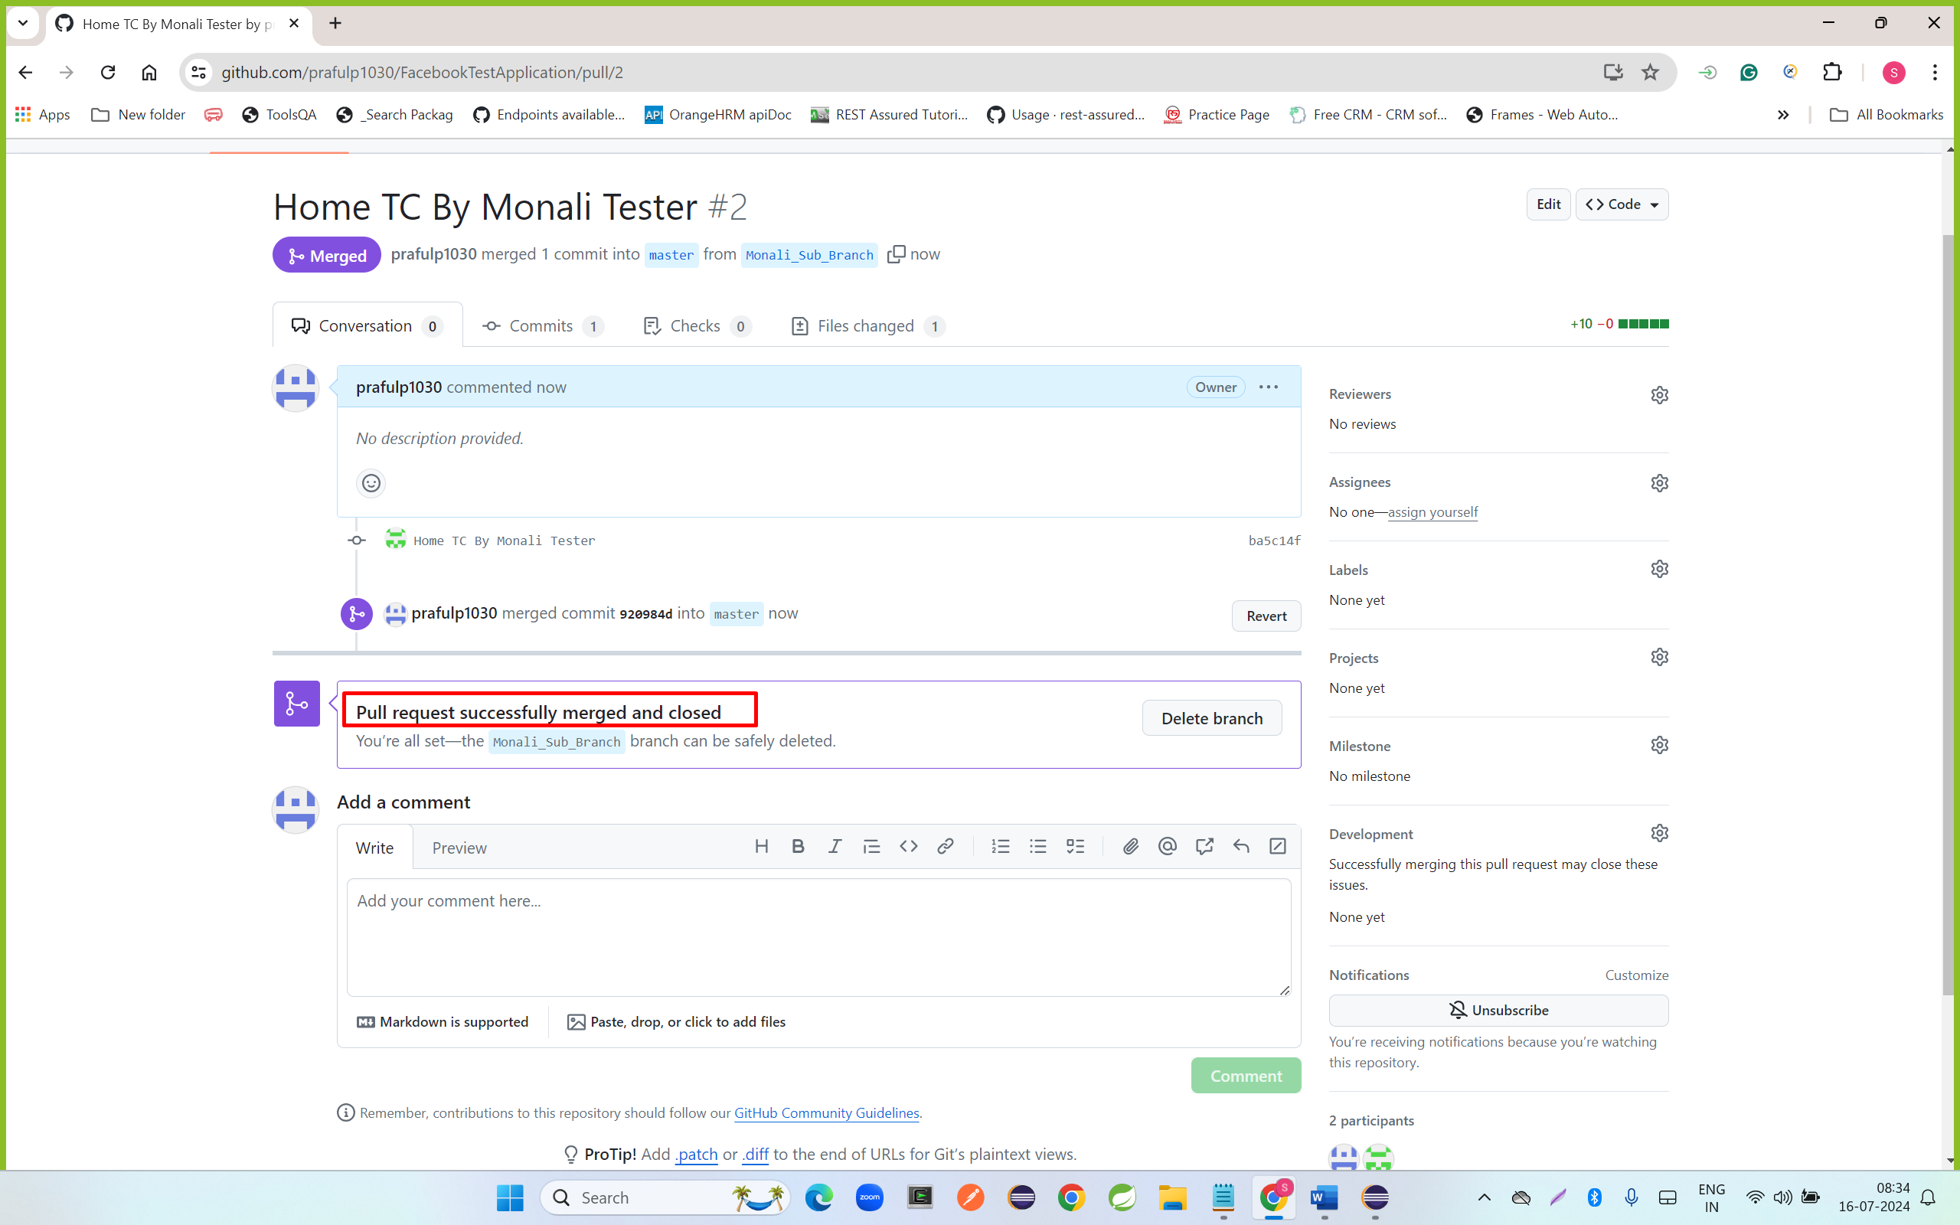

**Suraj Automation tester**

* Checkout to master branch

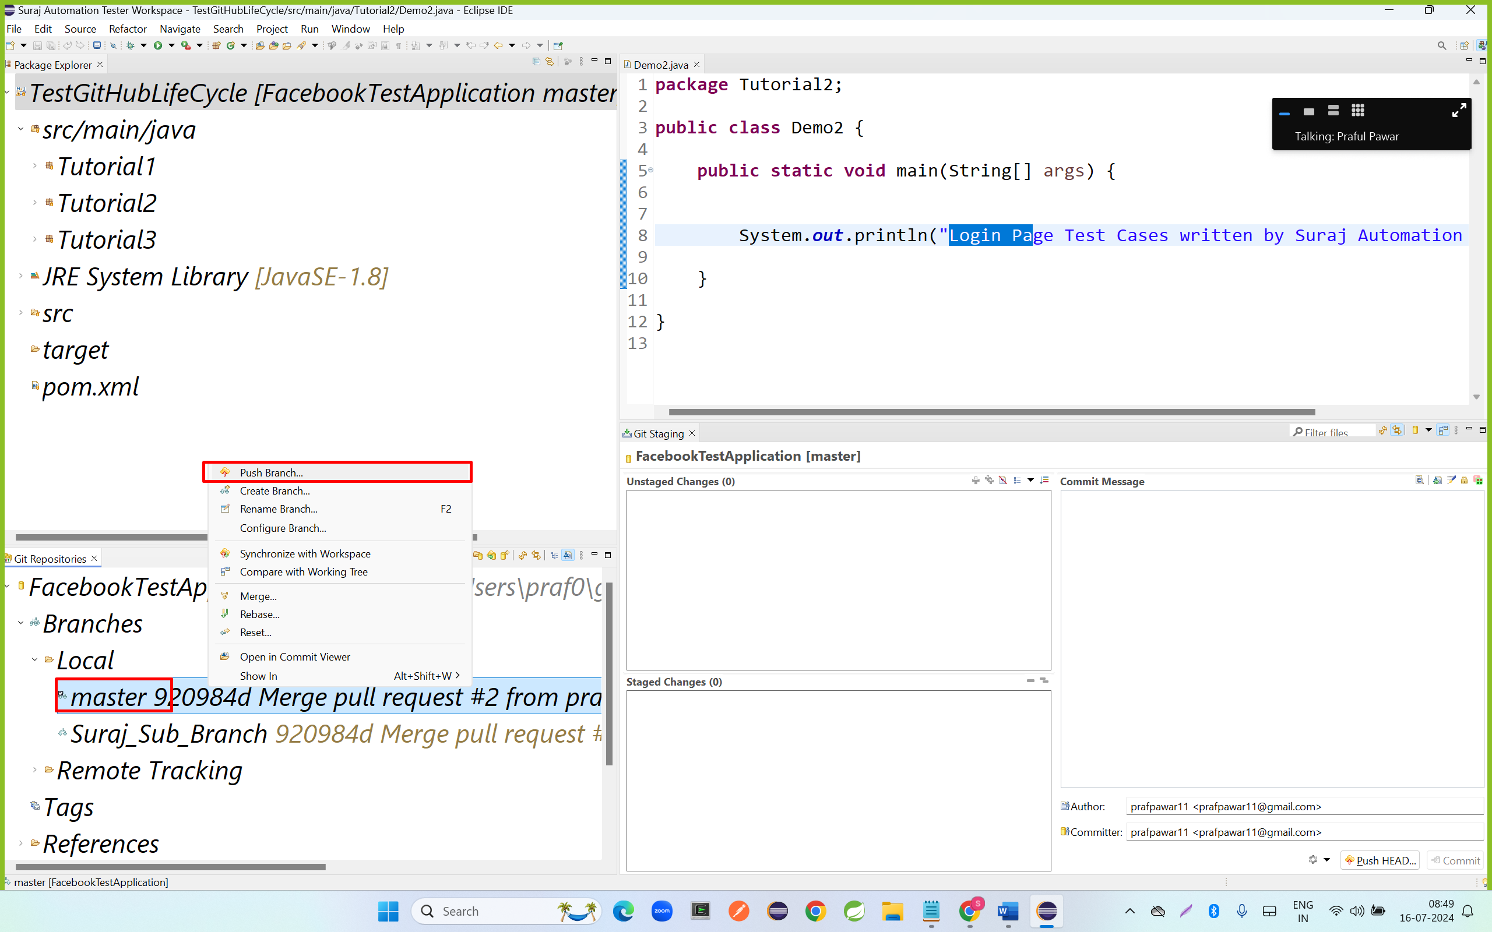

Step 2: pull latest code from Remote GitHub Master Branch to Git Local Master branch

* Right click on project – go to team – click on pull

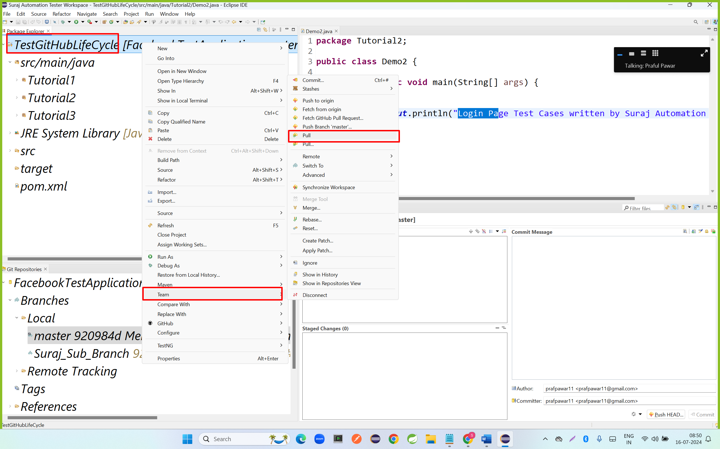

Checkout to Suraj Sub Branch

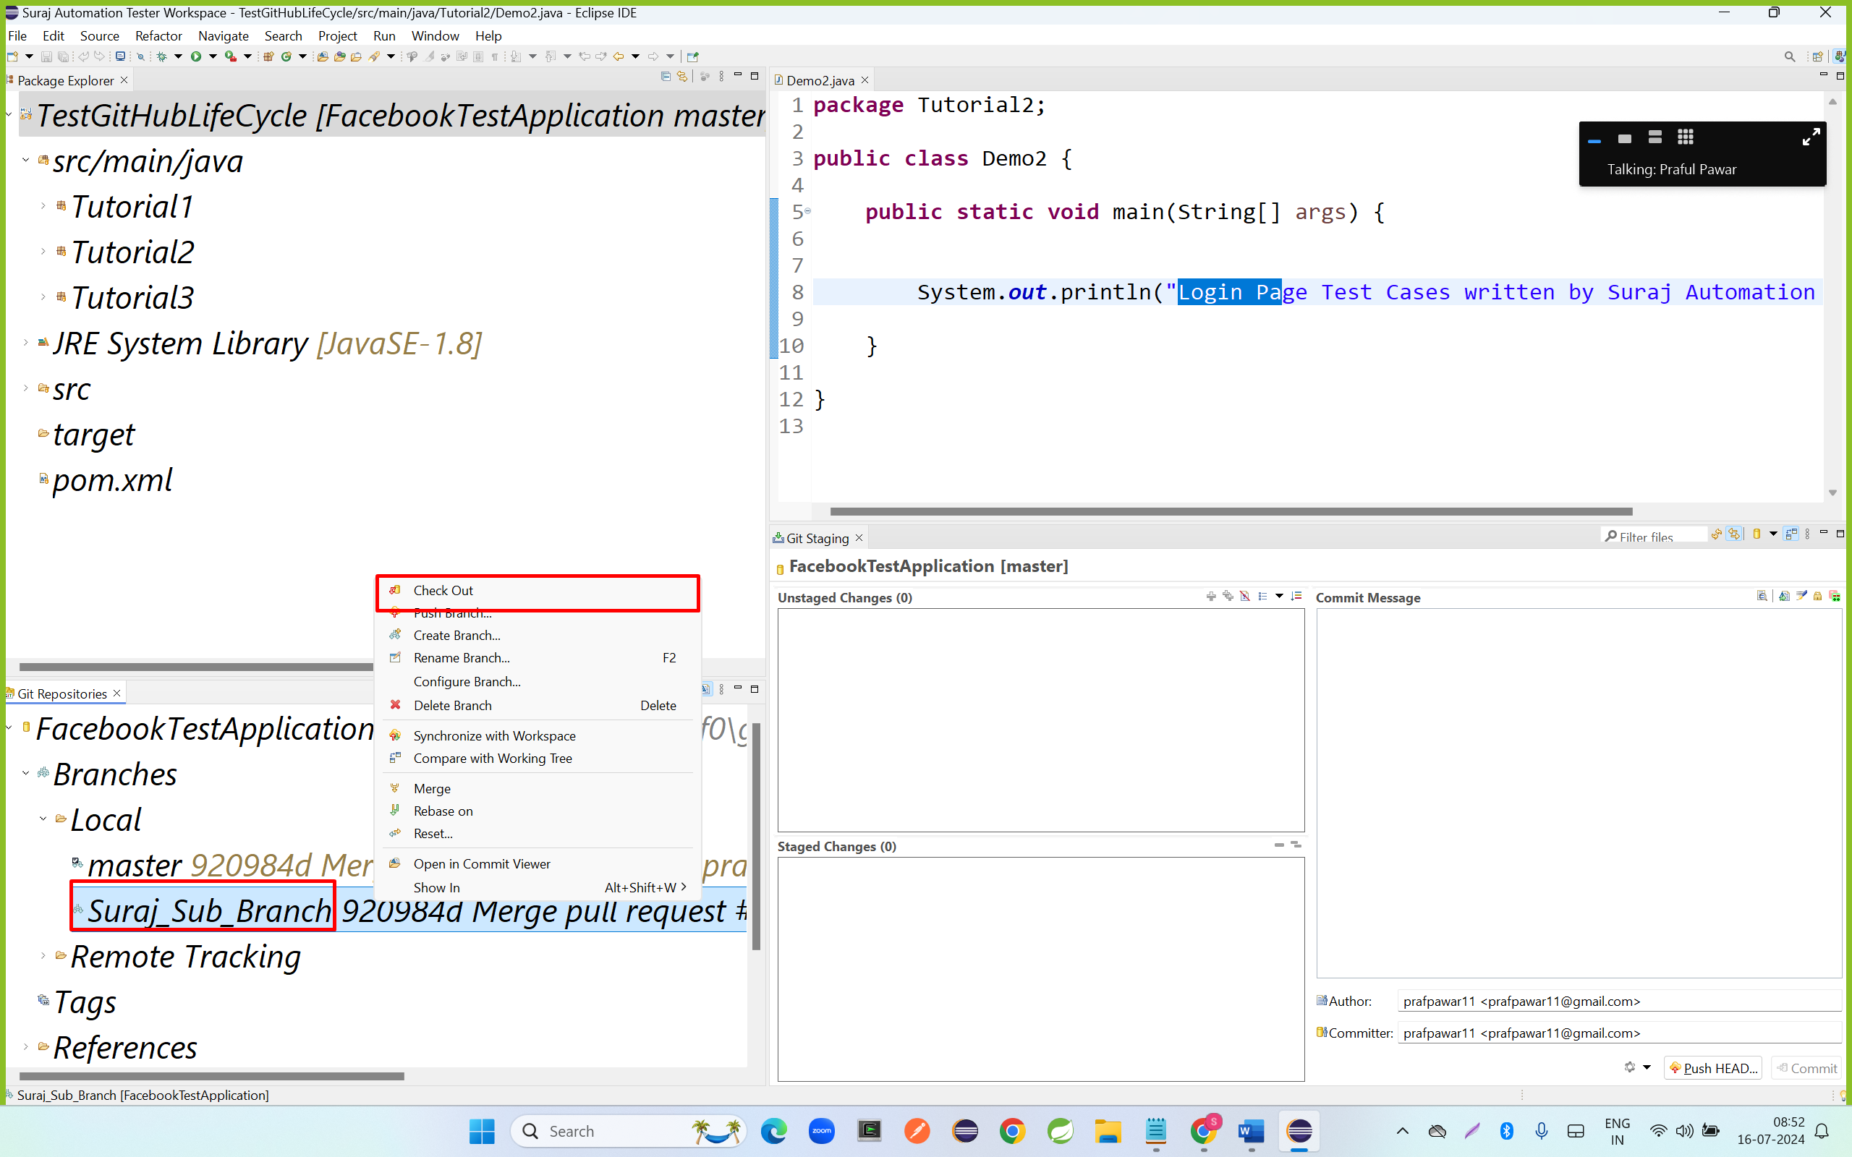

**Merge code from Master Git Local Repository to Suraj Git Local Repository**

* Right click on project name – go to team – click on merge

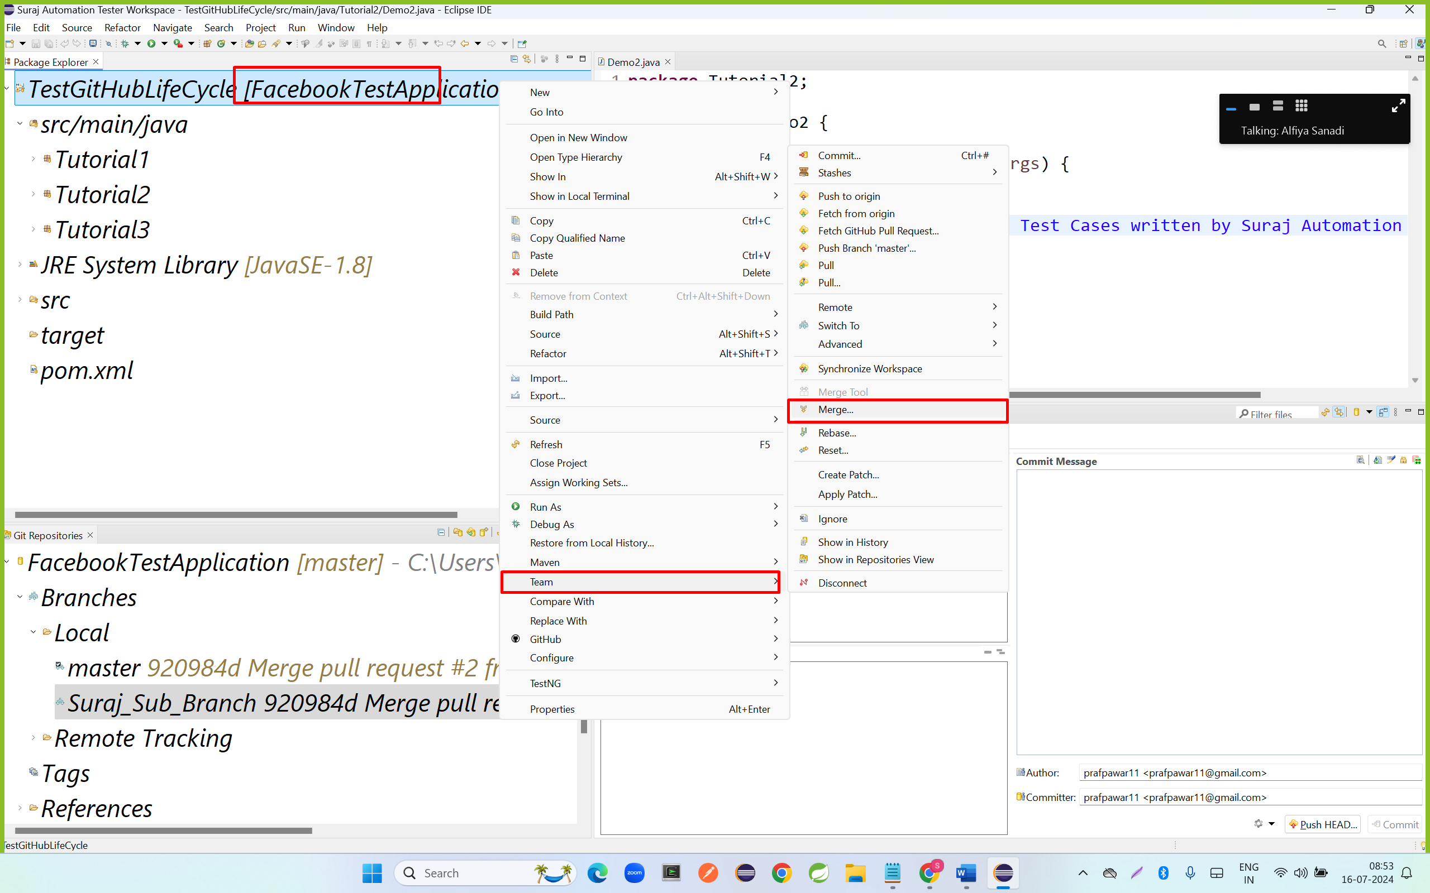

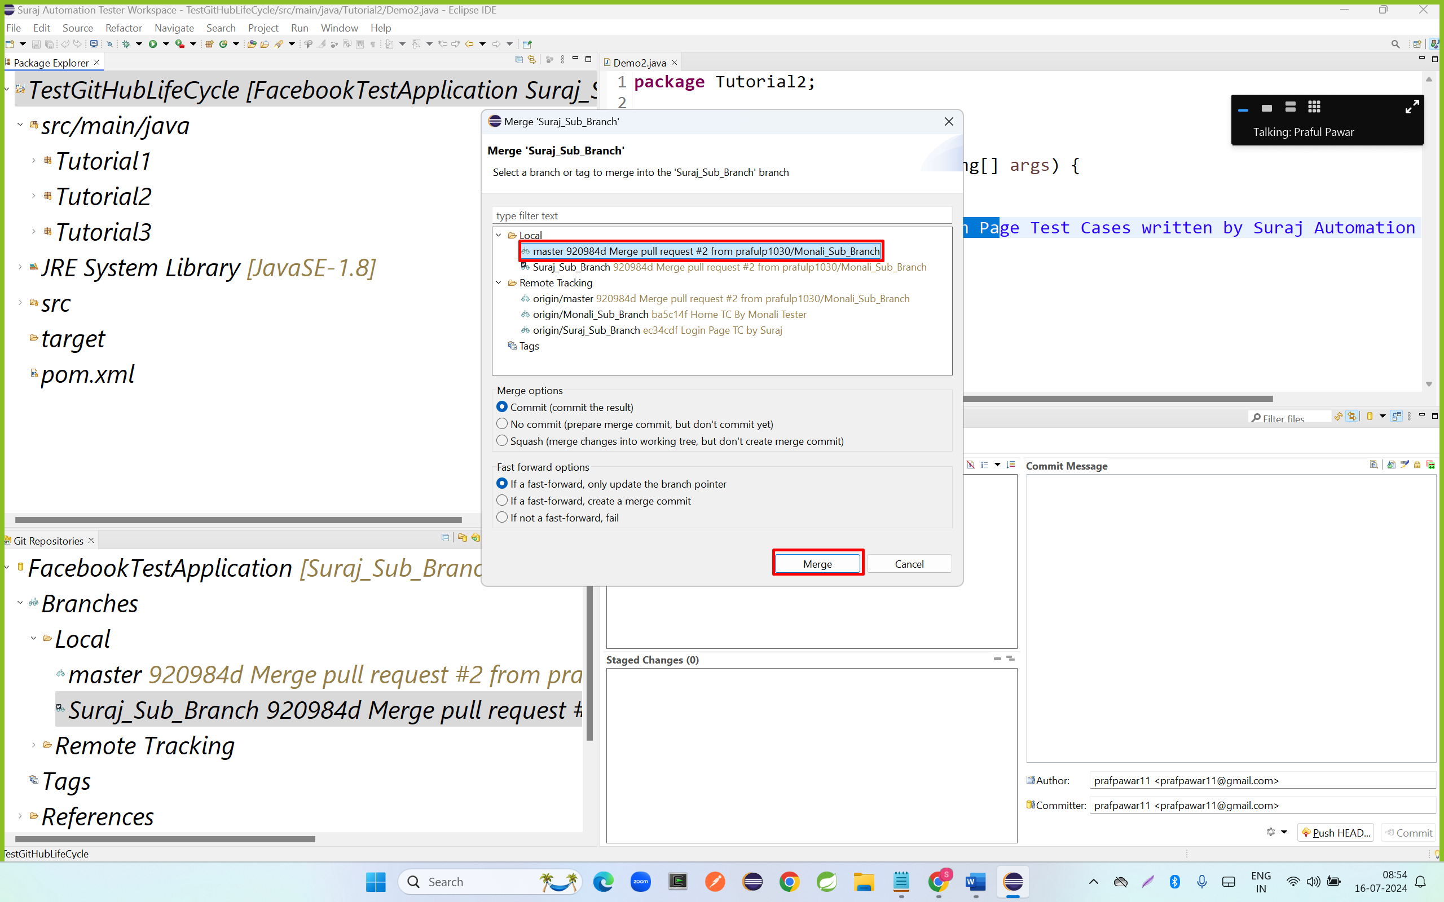

* Create the test cases
* Add files to stagging area
* Commit code to local git repository
* Push code to Remote Suraj Sub branch
* Reviews the code
* Go to GitHub
* Go to Suraj Sub branch
* Click on compare and pull Request
* Verify the From and To pull branch Names
* Enter the Message
* Click on create pull request
* Click on confirm pull Request